
MercyOne North Iowa Medical Center FY26-28 Community Health Needs Assessment

Table of contents
Executive summary 4
Significant community health needs 4
Prioritized needs 4
About us 5
Mission Statement 5
Core Values 5
MercyOne North Iowa Medical Center 5
Advisory Committee 7
Summary of previous needs assessment 7
Community description 10
Geographic area 10
Population characteristics 11
Assessment process 13
Input from community members 13
Written comments 9
Quantitative data gathering 16
Indicator data summary 17
Primary data summary 17
Secondary data summary table 41
Community assets and resources 59
Next steps 60

Executive summary
To ensure a meaningful, collaborative approach to best represent and serve our community, this Community Health and Needs Assessment (CHNA) is to be considered a CHNA-Lite. This CHNA-Lite contains relevant information to abide by IRS requirements and regulations. MercyOne North Iowa elected to conduct a CHNA-Lite in FY26 to align cycle timelines with the Cerro Gordo Public Health Department in their next cycle, taking place FY28. MercyOne North Iowa will work collaboratively with Cerro Gordo Public Health and the advisory committee to conduct the next CHNA, to align the service area. Cerro Gordo Public Health and the current advisory committee were engaged and involved in this most CHNA-Lite. The CHNA was presented to and adopted by the MercyOne North Iowa Medical Center Board of Directors on March 25, 2026.

Sixteen (16) significant health needs were identified based on the information gathered through community input survey, focus groups and review of secondary data. Members of the steering team were asked to rank each of the 16 identified health needs from 1-16, with 1 being highest priority and 16 being lowest priority. Advisory team participants were asked to rank based on the following criteria: Number of people impacted, the risk of morbidity and mortality, impact on vulnerable populations, importance to the community, and feasibility of change. The significant community health needs, ranked order of priority, include:
- Food/Nutrition
- Cancer
- Mental Health
- Smoking/Vaping
- Insurance
- Transportation
- Obesity
- Aging
- Childcare
- Diabetes
- High Blood Pressure/Heart Disease
- Access to Healthcare
- Violence/Harassment/Bullying
- Drug Use/Misuse
- Dentistry
- Housing/Homelessness

Printed copies of this report are available upon request at MercyOne North Iowa Medical Center. This report is also available electronically at https://www.mercyone.org/about-us/community-health-and-well-being/
Please email questions, comments and feedback to communityhealth@mercyhealth.com.

About us

Our Mission
We, MercyOne, serve together in the spirit of the Gospel as a compassionate and transforming healing presence within our communities.

Our Vision
As a mission-driven innovative health organization, we will become the national leader in improving the health of our communities and each person we serve. We will be your most trusted health partner for life.

Our Core Values
- Reverence: We honor the sacredness and dignity of every person.
- Commitment to Those Experiencing Poverty: We stand with and serve those who are experiencing poverty, especially those most vulnerable.
- Safety: We embrace a culture that prevents harm and nurtures a healing, safe environment for all.
- Justice: We foster right relationships to promote the common good, including sustainability of Earth.
- Stewardship: We honor our heritage and hold ourselves accountable for the human, financial and natural resources entrusted to our care.
- Integrity: We are faithful to who we say we are.

MercyOne North Iowa Medical Center
MercyOne is a connected system of health care facilities and services dedicated to helping people and communities live their best lives. The system’s more than 220 clinics, medical centers, hospitals and care locations are located throughout the state of Iowa and beyond. MercyOne employs more than 22,000 colleagues. MercyOne is a member of Trinity Health based in Livonia, Michigan.

MercyOne North Iowa Medical Center is a faith-based, full-service community medical center serving residents of northern Iowa. We offer ambulatory care through our MercyOne Family Medicine Clinics (primary care and specialty physician network), home health agency, hospice, regional referral laboratory, regional rehabilitation and diagnostic technology services, pharmacies, an emergency services network and a variety of other health care services.

MercyOne North Iowa Medical Center offers numerous specialty services including a cancer center, a health center, a vascular and wound center, neurosurgery, behavioral health and more. MercyOne is the largest provider of health care services in our region, and we are proudly the largest employer in Cerro Gordo County.

Our hospital is a private, not-for-profit health care center, licensed for 346-beds, which serves more than 400,000 inpatients and outpatients each year. MercyOne North Iowa Medical Center is also a teaching institution with a Family Medicine Residency, Internal Medicine Residency, Cardiology Fellowship, Hospice and Palliative Medicine Fellowship, PGY1 Pharmacy Residency and a School of Radiologic Technology.

MercyOne North Iowa Medical Center is a clinical training site for approximately 500 students from 127 different colleges enrolled in programs for medical laboratory, nursing, paramedics, rehabilitation, medical assistants, pastoral services, physicians, and many other medical fields. MercyOne holds management agreements with seven rural primary care hospitals, making us the premier rural health care delivery network in northern Iowa.

Affiliated Hospitals: Franklin General Hospital, Hancock County Health System, Hansen Family Hospital, Kossuth Regional Health Center, MercyOne New Hampton Medical Center, Mitchell County Regional Health Center and Palo Alto County Health System.

Hospitals and the employees in the health sector contribute to large quantities of goods/services purchased from local businesses. These impacts are referred to as secondary impacts. According to Iowa Hospital Association 2024 Economic Impact report for Cerro Gordo County, (Economic Impact and Community Benefits | Iowa Hospital Association) 17.5% of all 4,161 jobs come from the hospital and 28.7% of the $359.1 million total wages come from this hospital. MercyOne colleagues purchase 32.1% of goods/services of the total $890.2 million in the community.

Advisory Committee
Thank you to our community and public health partners for their active engagement in the assessment process:
- Cerro Gordo Public Health: Kara Vogelson, Mindi Watters, Karen Cummings
- North Iowa Community Action: Cindy Davis
- Hancock County Public Health: Chelcee Schlueger
- Palo Alto County Public Health: Donna Weig
- Floyd County Public Health: Gail Arjes
- Winnebago Public Health: Julie Sorenson
- Prairie Ridge: Kelly Grunhovd
- Community member with lived experience
- Kossuth County Public Health: Lynzie Plathe
- Kossuth County Public Health: Mercedes Becker

*Please note that MercyOne North Iowa Medical Center’s Advisory Committee is the same Advisory Committee for Cerro Gordo Public Health (and previous Community Health Needs Assessments/Implementation Strategy).

Summary of previous needs assessment
The MercyOne North Iowa Medical Center Board approved the previous Community Health Needs Assessment (CHNA) on June 14, 2023. The significant health needs identified in the FY23-FY25 CHNA, in order of priority, include:
- Mental Health Support
- Food Access
- Aging Support
A wide range of priority health and social issues emerged from the CHNA process. MercyOne North Iowa Medical Center determined that it could effectively focus on only those needs which were most pressing, under- addressed and within its ability to influence. MercyOne North Medical Center, in collaboration with community partners, chose to focus on initiatives addressing the following need:
- Mental Health Support
The table below highlights actions taken over the succeeding three (3) years to address selected needs as well as the impact of those actions:

Prioritized Need | Progress
Mental Health Support | MercyOne North Iowa Medical Center has continued involvement in the county mental health work group. The work group started “toilet talks.” These toilet talks are completed quarterly, providing mental health information and resources. The toilet talks are distributed throughout the community and schools. There is work being done in the community with businesses and organizations, specific to mental health. Free training has been offered. The work group conducted surveys with the senior population and found many are experiencing depression/loneliness. Time was spent exploring how we could get youth groups involved with the seniors to address the issue of loneliness. Many challenges were faced with this, and the work group has since shifted focus. The work group has developed mental health tool kits, distributing these throughout the community. The mental health work group is currently working to develop a resource guide specifically for neurodivergent children and children with autism.  A new Child Psychiatrist, Dr. Duregger, has been recruited and on board. MercyOne North Iowa has a psychologist with expertise in psychological testing, including Autism Spectrum Disorder (ASD) evaluations, Dr. Brandau-Harrell.  MercyOne North Iowa has focused heavily on optimizing psychological testing scheduling and completed visits. New processes were put in place to better prioritize the requests to ensure that the most time-sensitive needs can be addressed quickly. As a result, testing waitlists have been reduced from more than 700 patients to approximately 450.  MercyOne North Iowa has a behavioral health representative participating in weekly meetings with our community partners and local law enforcement to review high-need patients, collaboratively working to reduce barriers to treatment.  MercyOne North Iowa Psychiatry Office has been transitioned under the Bhservice line. The change aligned Outpatient Behavioral Health, Psychiatry, and Crisis Services. Improvements in continuity of care have been notable.
 | MercyOne North Iowa Medical Center participated in the Make it OK campaign and annual walk, working to reduce the stigma. MercyOne has been involved in several events, providing information and education on mental health.
 | MercyOne has provided restricted financial contribution to 43 North Iowa and Northern Lights Alliance for the Homeless. Both organizations provide services to the community members who are facing mental health challenges.

Written comments
MercyOne North Iowa Medical Center did not receive any written comments regarding the FY23-FY25 Community Health Needs Assessment or Implementation strategy. The documents continue to be available on the MercyOne website at https://www.mercyone.org/about-us/community-health-and-well-being/ and printed copies are available upon request at MercyOne North Iowa Medical Center.

Community served

Geographic area

Within this geographic area, there are two MercyOne Medical Centers, MercyOne North Iowa Medical Center located in Mason City and MercyOne New Hampton Medical Center. MercyOne North Iowa is affiliated with, and contract manages six additional hospitals. All these hospitals provide primary health care services. MercyOne maintains clinics throughout these counties, resulting in a natural referral center for this entire area while providing primary care services in local communities. Although MercyOne has patients throughout the 14 counties, the highest percentage are within Cerro Gordo County, which is why the focus is on Cerro Gordo County.

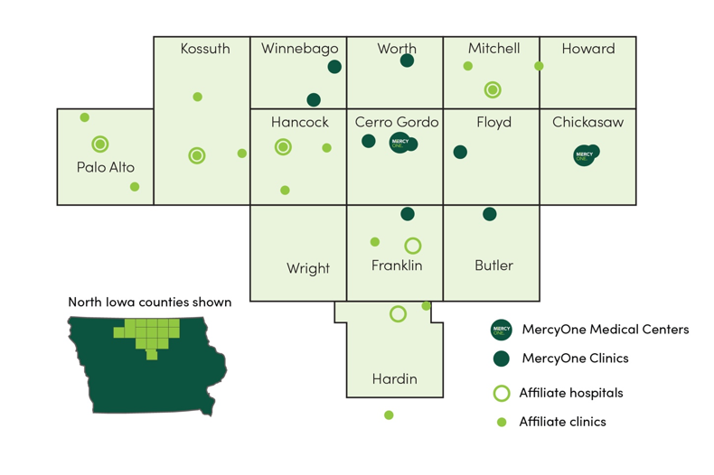

Population characteristics
The total population of Cerro Gordo County, as recorded on the most recent census in 2019-2023, is 42,785. Cerro Gordo has a population density of 75 per square mile. Of the total population, 5.32% are ages 0-4, 15.63% ages 5-17, 56.04% ages 18-64, and 23.01% 65 and older. Of the population of 18-64, 91% are white, 1.5% Black or African American, 1.6% Asian, 1.7% other and 3.8% Multiple Race. Cerro Gordo County’s population with any disability is 14.41%, which is above the state (12.40%) and national average (13.04%). The female population in Cerro Gordo County is55.05% and male population is 57.04%. The county’s population (age 5+) with limited English proficiency percentage is .76%, which is lower than both the state and national average. Veterans make up 7.28% of Cerro Gordo population. Of those, 18.40% are 75 years or older. A total of 11,042 Medicare Beneficiaries in Cerro Gordo County. Of those, 12.57% are eligible for Medicaid.

The below table summarizes the demographics of Cerro Gordo County using Data source: US Census Bureau, American Community Survey. 2019-23.

Race (age 19-64)
White | 91%
Black or African American | 1.50%
Asian | 1.60%
Some other race | 1.70%
Two or more races | 3.80%
Age
Under 18 | 20.95%
18-64 | 56.04%
65 and older | 23.01%
Sex (age 18-64)
Male | 57.04%
Female | 55.05%
Population characteristics
Foreign-born population | 2.13%
Population 5+ with limited English proficiency | 0.76%
Veterans | 7.28%
Population with a disability | 14.41%
Geography
Population per square mile | 75

Assessment process

Community input
MercyOne North Iowa Medical Center collected community input through a 33-question survey. A total of 236 responses were collected between July 15, 2025, through September 15, 2025. Surveys were distributed to community members and organizations throughout Cerro Gordo and MercyOne North Iowa Medical Center service area. Flyers with the survey QR code were dispersed throughout the community. Many community partners shared the information internally and publicly. The local news station had information on the CHNA and how to participate. A few of the Micronesian leaders were contacted and encouraged to complete the survey. A copy of the survey is included in the Appendix.

The zip codes below are represented in survey responses.

Zip codes
50401 | 50401 | 50401 | 50436 | 50440 | 50457 | 50469 | 50450 | 50619 | 52132
50402 | 50402 | 50402 | 50438 | 50441 | 50458 | 50479 | 50456 | 50633 | 56006
50522 | 50522 | 50522 | 50439 | 50446 | 50464 | 50449 | 50482 | 50659 | 50643
50461 | 50466 | 50472 | 50475 | 50060 | 50054 | 50072 | 59401 | 50461

The table below summarizes the demographics of survey respondents.

Sex
Male | 18.10%
Female | 81.47%
Other | 0.43%
Age
18-64 | 78.73%
65 and older | 21.27%
Median age | 52
Household Income
0-$15,000 | 3%
$16,000-$24,999 | 5%
$25,000-$49,999 | 19%
$50,000-$74,999 | 21%
$75,000-$100,000 | 19%
Over $100,000 | 33%
Race
White/Caucasian | 97.41%
Black or African American | 0.43%
American Indian/Alaskan | 0.43%
Asian | 0.43%
Hispanic | 0.86%
Other | 0.43%
Education
Less than high school | 0%
High school graduate or GED | 9%
Some college | 16%
Associate degree | 18%
Bachelor degree | 33%
Graduate degree | 24%
Healthcare coverage (all that apply)
Through employer | 47%
Medicare | 14%
Privately purchased | 5%
Medicaid or other state program, | 2%
TRICARE, VA, or Military | 1%
Dental | 16%
Vision | 13%
Other (spouse) | 1%
Uninsured | 1 person
Work status

Unemployed and seeking work | 1%
Part time or temporary work | 7%
Full-time work | 70%
Unemployed but no seeking work (e.g. Retired, disabled, student, unpaid primary caregiver) | 22%

MercyOne North Iowa Medical Center collected community input through three focus groups held on September 2 and September 3. Focus groups were held at the Community Kitchen (over 25 participants and several volunteers), Norther Lights for the Homeless Shelter (15 participants and two staff) and 43 North Iowa (six participants). Summary of the focus group findings can be found on pages 32-37. MercyOne North Iowa Medical Center made numerous attempts to connect with the Micronesian population through the local leaders. Although several conversations occurred, no data was received.

Quantitative data gathering
Secondary data, comparisons and benchmarks include figures and interpretation from the following sources:
- American Community Survey Five-Year Estimates
- Center for Applied Research and Engagement Systems (CARES)
- Centers for Medicare and Medicaid Services
- Centers for Disease Control and Prevention
- County Health Rankings & Roadmaps
- State of Childhood Obesity
- Feeding America
- Federal Bureau of Investigation
- Healthy People 2030
- Iowa Department of Public Health
- Iowa Data Center
- Kids Count Data Center
- MercyOne Community Input Survey
- National Center for Health Statistics
- National Center for Education
- Robert Wood Johnson Foundation
- State Cancer Profiles
- State Health Registry of Iowa
- U.S. Census Bureau
- U.S. Department of Education
- U.S. Department of Health and Human Services
- U.S. Department of Labor
- U.S. Environmental Protection Agency

Indicator data summary

Primary data survey and summary

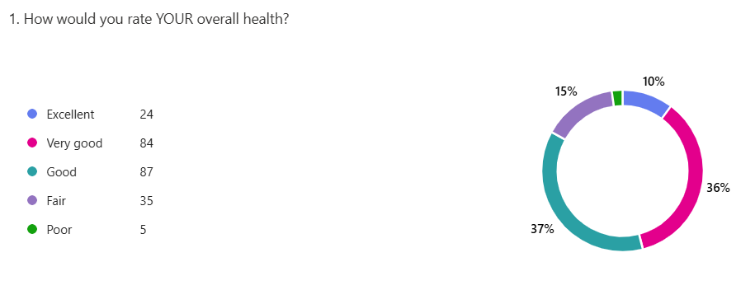

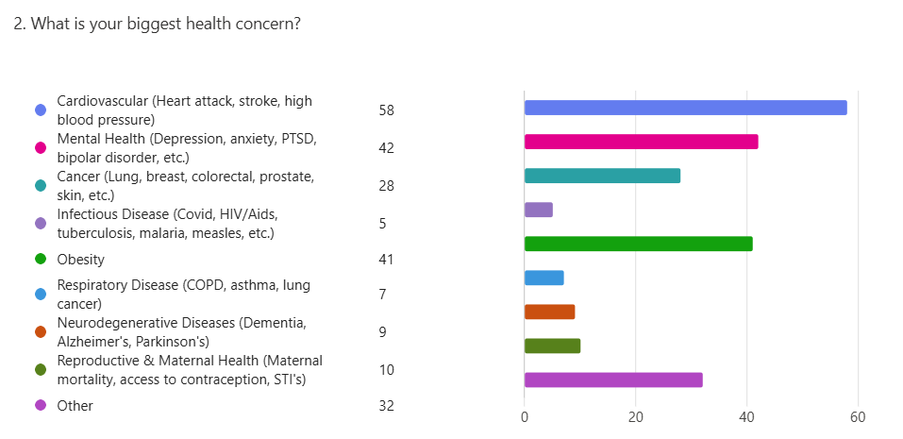

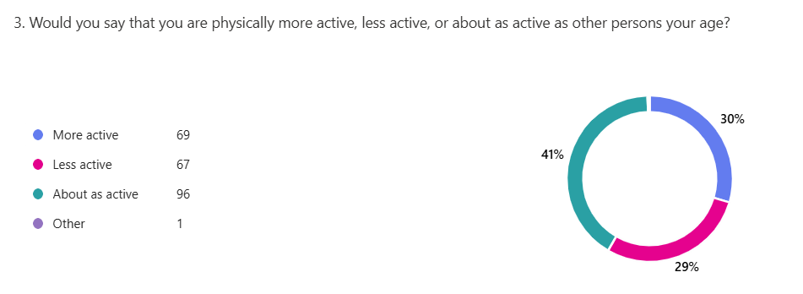

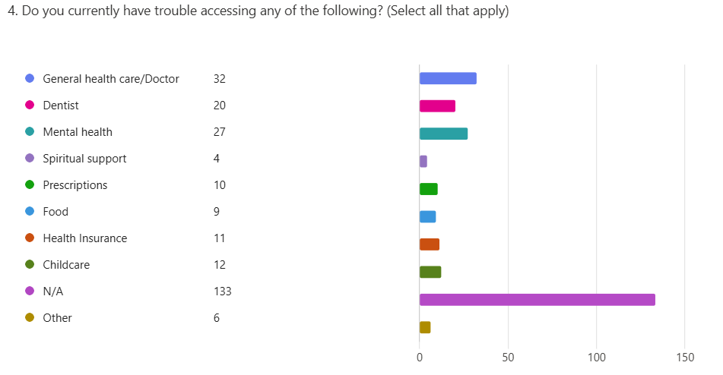

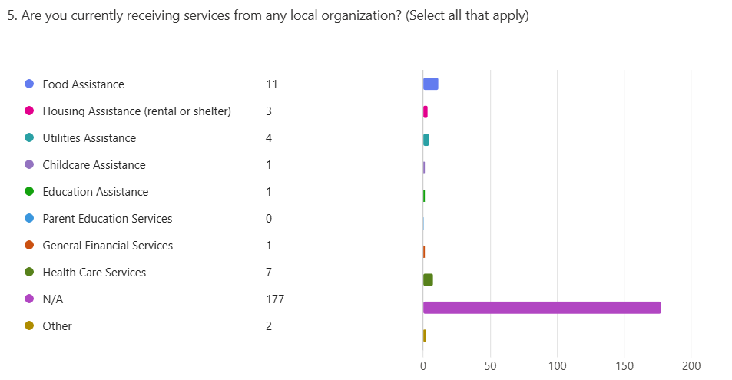

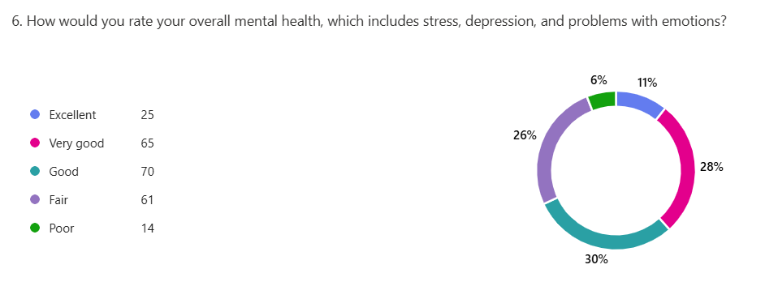

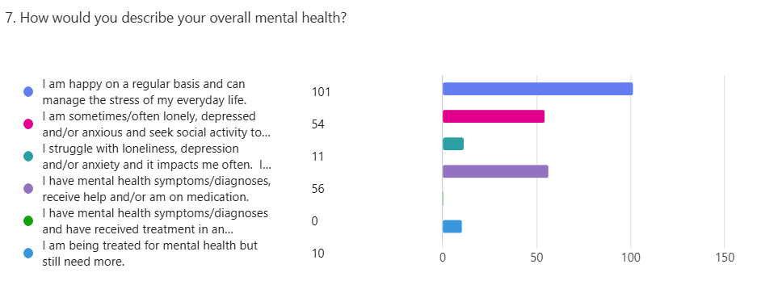

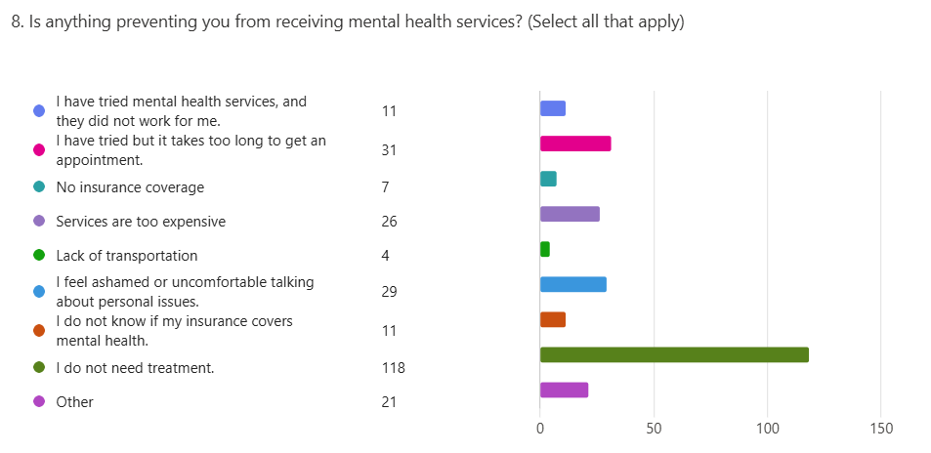

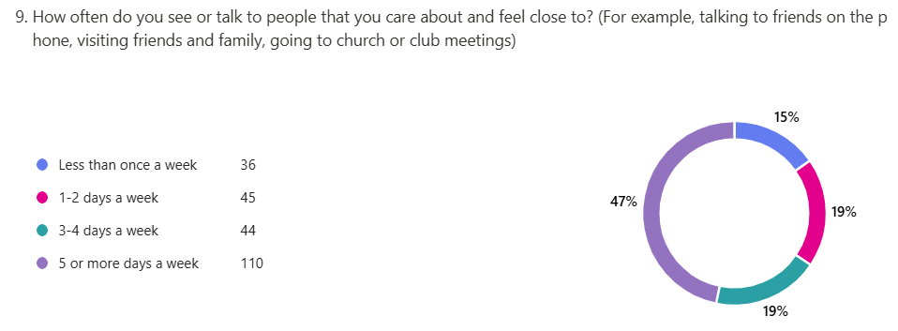

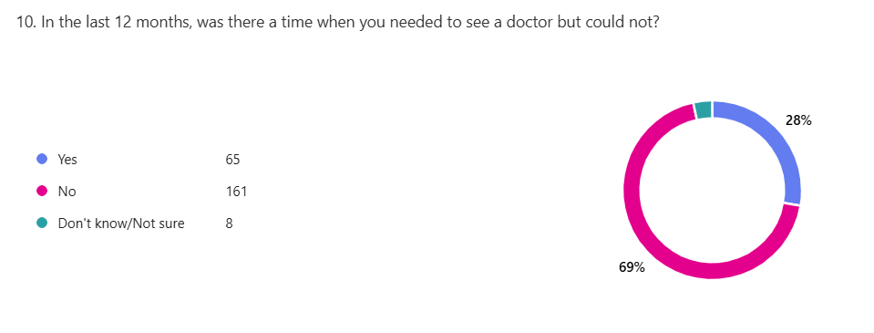

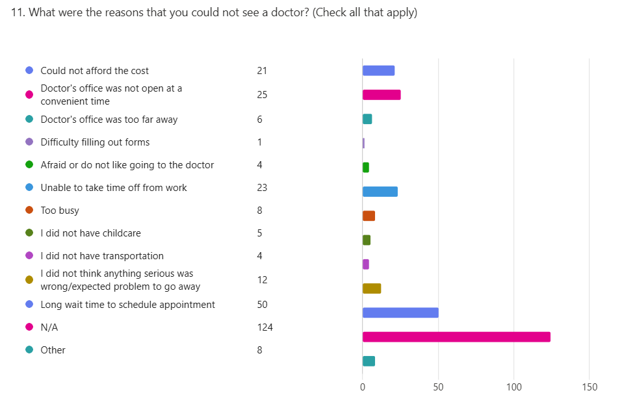

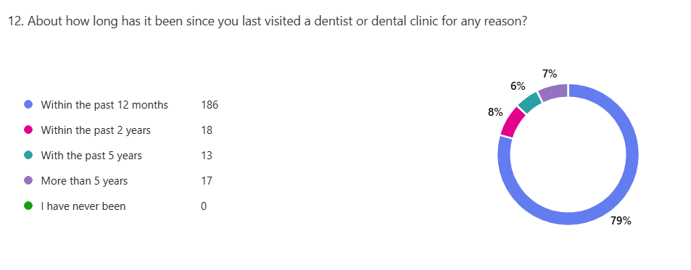

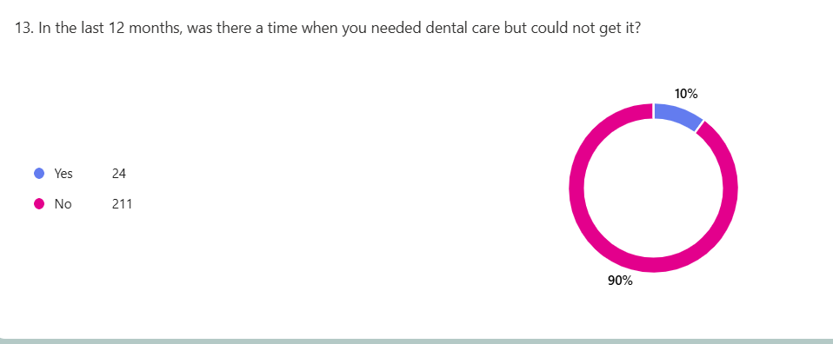

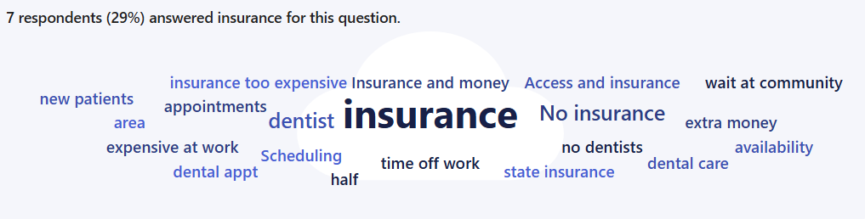

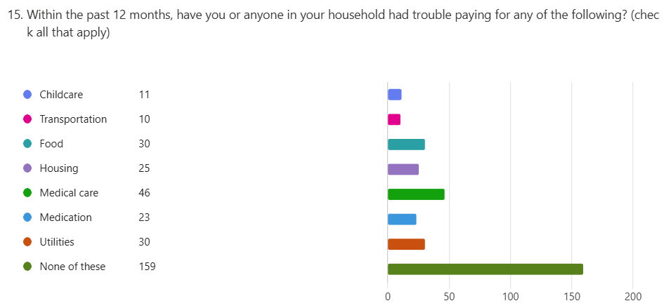

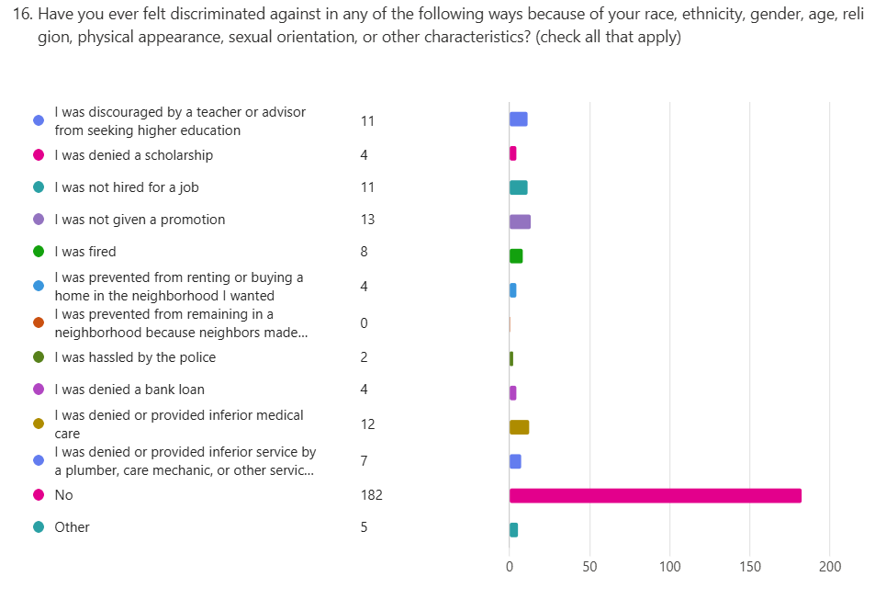

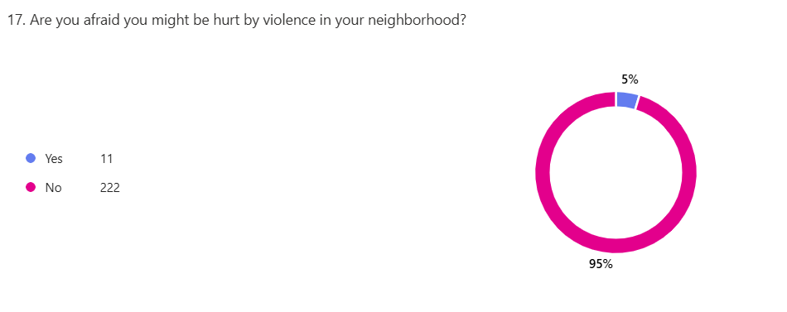

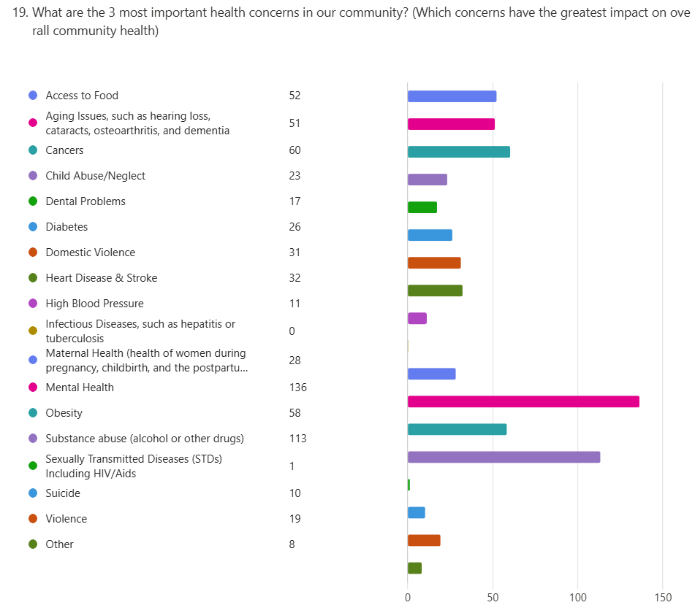
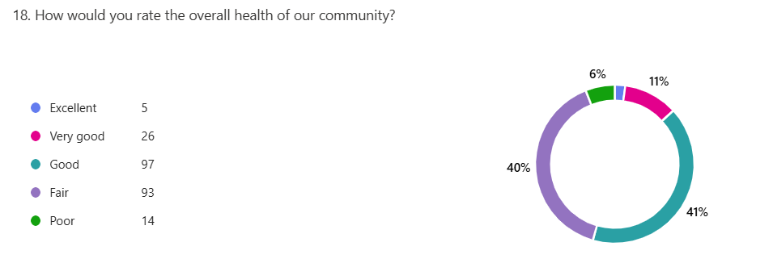
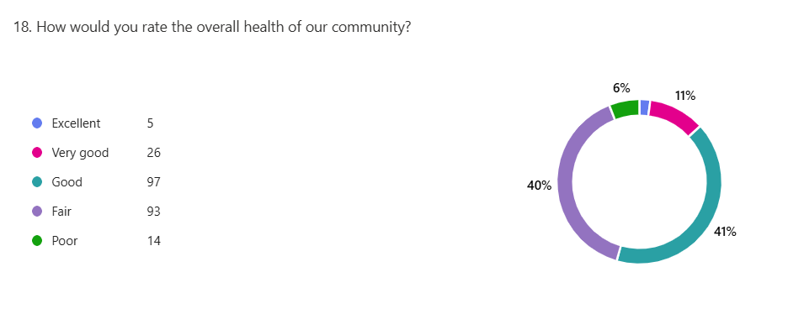

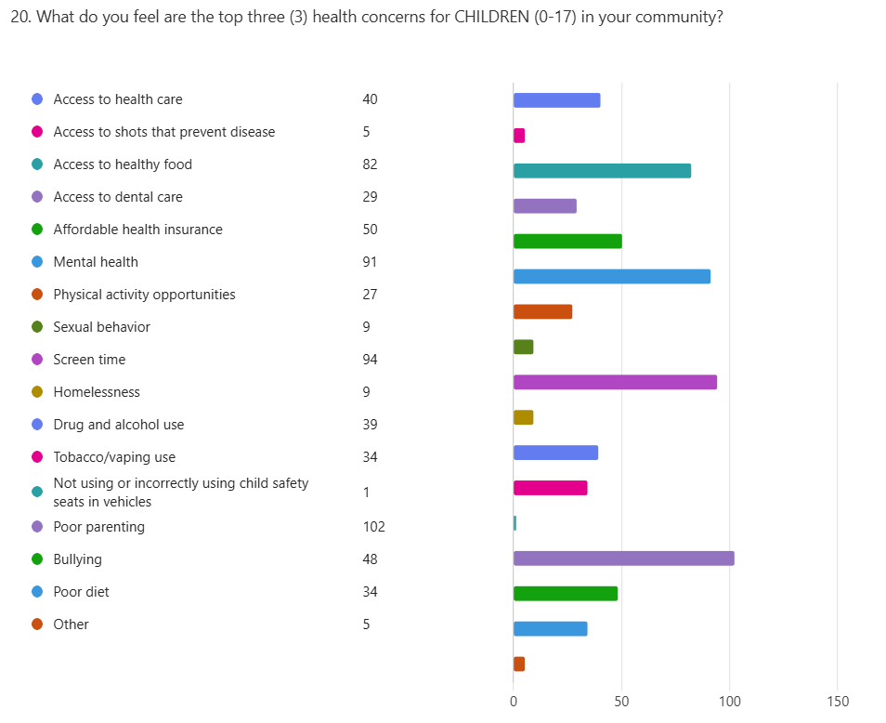

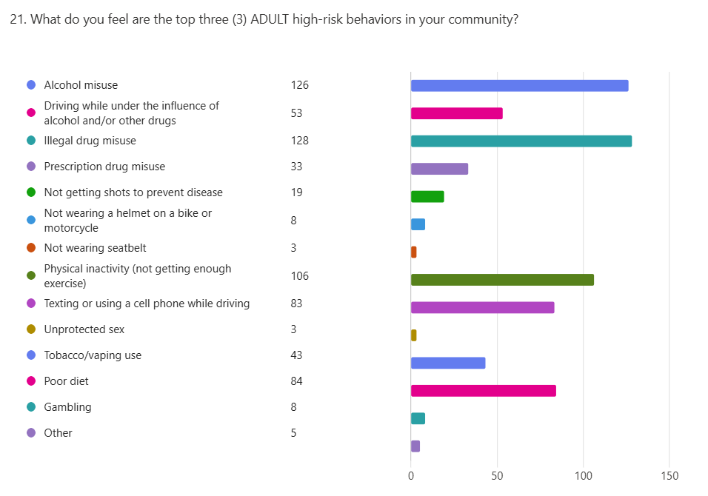

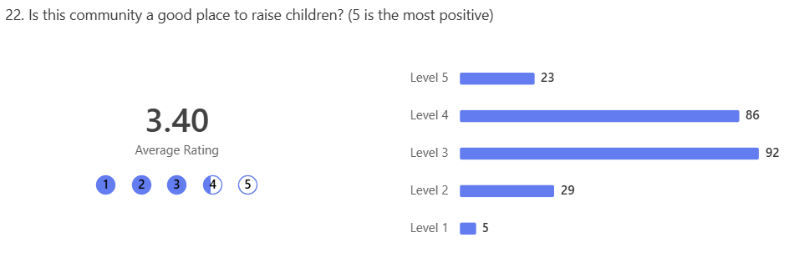

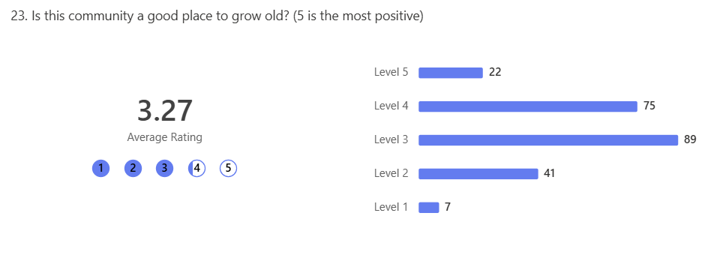

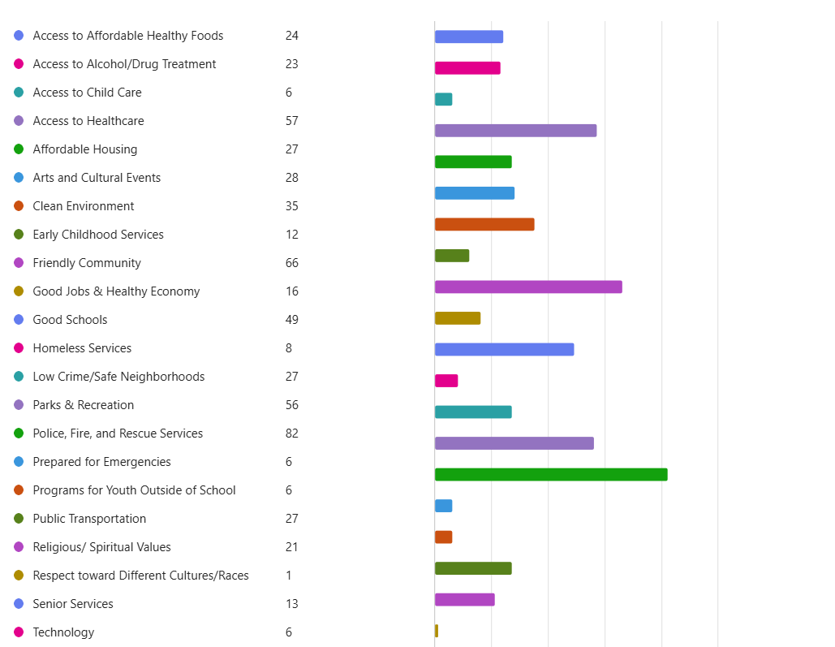

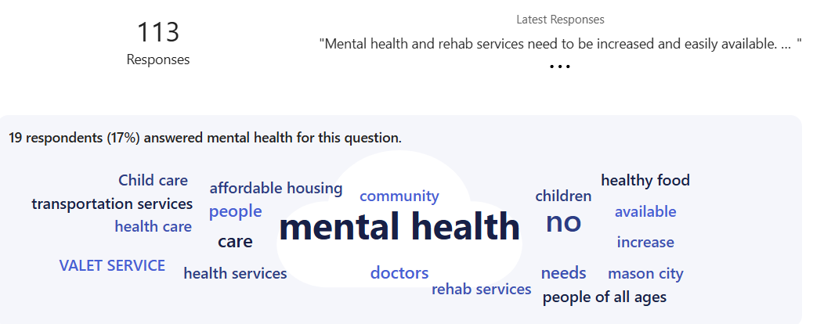

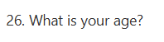

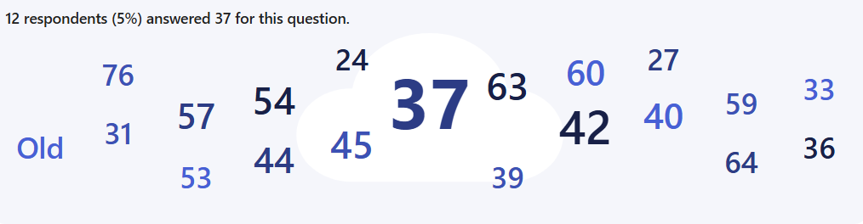

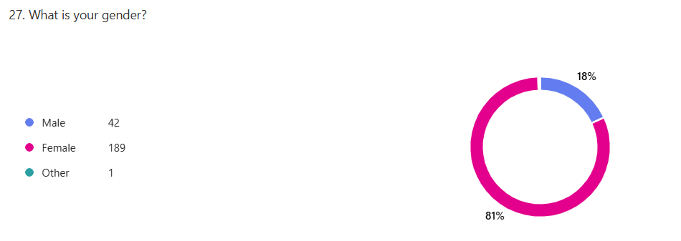

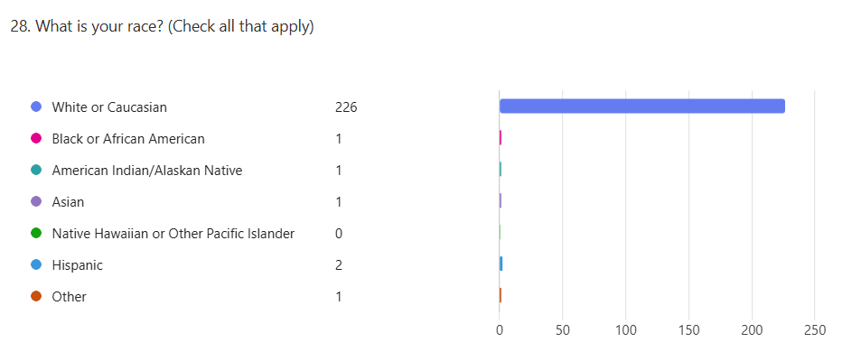

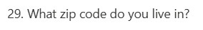

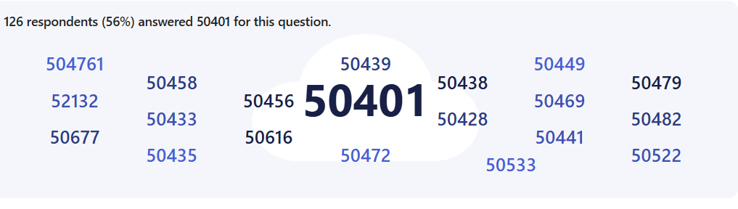

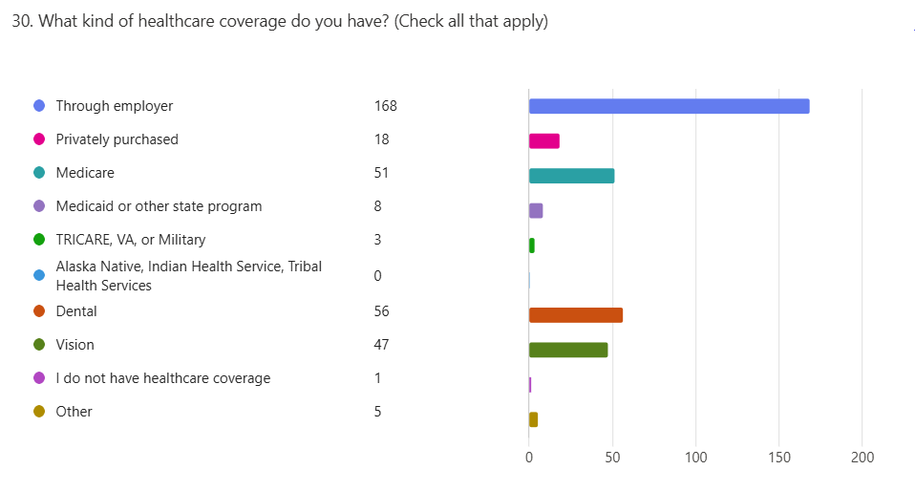

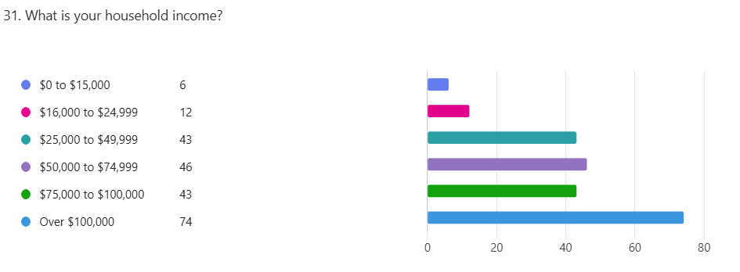

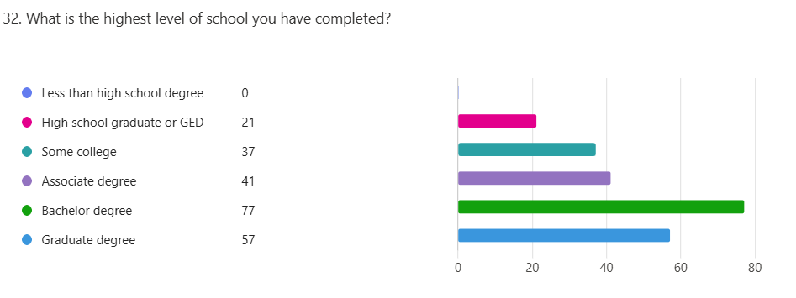

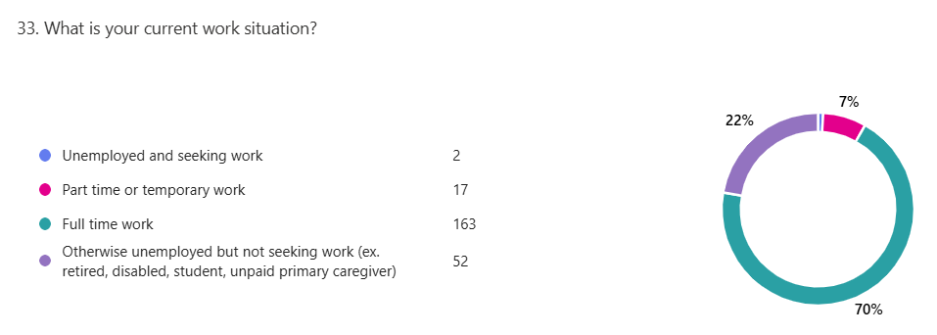

Community Health Needs Assessment
Focus Group: Northern Lights Alliance for the Homeless Shelter
Date: Sept. 2, 2025
Participants: 15 and two staff

- What are the biggest health challenges people in this community face (chronic illness, mental health, substance abuse, access to care).

- Diabetes
- Drug addiction
- Mental Health
- Healthcare
- Dentistry
- Lack of general resources
- Homelessness
- What state insurance pays
- Lack of knowledge of resources
- Not being able to get mental health care, especially when in crisis
- Suicidal individuals do not get the care they need
- “You can’t be living on the streets without being high or drunk.”
- One participant talked about being homeless and needing to stay high so you stay awake to ensure you are safe (if you sleep something could happen).
- People’s background and how it stays with you, not recognizing people can change without judgement.
- Past criminal background leads to judgement

- What barriers do people in this community face when trying to get healthcare or stay healthy?

- Medicaid/care coverage
- No phone
- No address (homeless)
- People’s past (history)
- Cost of health care
- Lack of knowledge of community resources
- “Once out here it is different.” “It has definitely humbled me.”
- Specialty care is hard to get into due to access (capacity).
- Lose track of people because in time crunch while at the shelter and then they fall through cracks because they leave shelter and there is no way to get in touch with them.
- People lack understanding of their insurance.

- What resources or services do you feel are missing or not working well in this community?

- Dentist that takes insurance. A lot do not take state insurance. No transportation to get to Iowa City.
- People are turned away because of their past records.
- Better benefits (need)
- Iowa needs to update their system (policy and laws)
- Shelters don’t accept animals, and some do not want to go without their pet.

- What ideas do you have for improving health and wellness in this community?

- Need respite shelter for pets (for those individuals who are homeless and need to go to the shelter)
- People using resources are involved in communication and what is going on.
- Everyone needs to take accountability.
- If suicidal, one can’t stay at the shelter. The hospitals turn them away and then they are left to not have a place to stay.

The residents at the shelter talked a lot about how hard it is being homeless. Discussed mental health and lack of services. There was discussion about how long it takes to get to services and how many fall through the cracks as they must leave the shelter and they have not yet heard back.

A lot of discussion about stigma and how people’s past sticks with them, even years later.

Community Health Needs Assessment
Focus Group: Community Kitchen
Date: September 2, 2025

- What are the biggest health challenges people in this community face (chronic illness, mental health, substance abuse, access to care).

- Insurance doesn’t cover half of my meds for diabetes
- Not enough clinics around in areas where the homeless are
- Lack of transportation
- Smoking/vaping
- Not having insurance
- Age (getting older)
- Mental health
- Lung problems
- Keeping driver’s license
- Age and ability to drive
- ER has long wait times
- COVID
- Housing (lack of)
- Transportation (inability to get to appointments due to no transportation)
- Lack of insurance

- What barriers do people in this community face when trying to get healthcare or stay healthy?

- Wait time
- Availability
- Food (lack of)
- Homelessness
- Doctors want to push pills vs. alternative medicine
- Price of food
- Doctors make money by pushing prescriptions. Need to look at morals
- Government money game (specifically related to food)
- Low barriers shelter
- Lack of knowledge. Some doctors care and some don’t
- Diabetic supplies (not always able to get this)
- Mental health services
- Insurance-co-pay
- No transportation
- No phone
- Insurance (lack of)
- Cost of food. It’s hard to buy food even when there are 2 working adults in the home.
- Need more flexible hours for medical care (medical appointments)

- What resources or services do you feel are missing or not working well in this community?

- Need more nutritionists and provide classes to help people understand
- Diabetic supplies
- Can redemption has disappeared since COVID
- Must reapply for aid (benefits)
- Mental health services
- Basic phone skills
- Affordable housing
- Slumlords
- Houses unkept- lack of maintenance
- Need resources to help with rent
- Not enough funds out there to help those in need
- Need a community center for socialization
- Lack of entertainment for older people within the community
- Need a ballroom for older people
- Need more services for homeless

- What ideas do you have for improving health and wellness in this community?

- Get new blood here (city government). They talked about the skywalk and that it goes nowhere.
- Decrease smoking- get people to quit
- Affordable food
- Elderly companionship
- Food
- Rent
- Immigrants
- Can’t afford food
- Better insurance
- Getting people more to be more active
- Free clinics and testing
- Teach people to play hacky sack as this is good to get people moving
- Need more sensible people to understand those in need. Too many look down upon others and don’t prioritize their needs
- Insurance covering what meds are prescribed
- Communication
- Having people (doctors) understand where others come from. Not everyone wants drugs (prescriptions).

Community Health Needs Assessment
Focus Group: 43 North Iowa
Date: September 2, 2025
Number of Participants: Six

- What are the biggest health challenges people in this community face (chronic illness, mental health, substance abuse, access to care).

- Insurance
- Mental illness
- “Psych wards just dope me up.”
- Insurance- how long it takes for it to get approved and be active
- Mental health (everyone in Mason City has mental health issues)
- Smokers (number of people who smoke)
- the bill (cost) if you got hurt and had to go to the ER
- violence, harassment & bullying
- Drug use in Mason City is worse than in a lot of other places
- Diabetes is a big issue.

- What barriers do people in this community face when trying to get healthcare or stay healthy?

- People do not know how to advocate for themselves.
- Language barriers
- People don’t know how to ask for help
- One pill is not one size fits all cure.
- Doctors throw meds at people rather than getting to the root cause
- Doctors do not take time to get to know their patients
- Need to go through all steps to get healthy, not just pill, maybe therapy, etc.
- Healthy amount of respect between patient and doctor (lack of)
- People don’t exercise
- Outside activity (do more) and less gaming
- Hard to find the right connections
- Time it takes to get assistance
- Family threatens to put their family members in assisted living, and this makes it hard to stay healthy
- More thoughts on individual are needed rather than one size fits all.
- Limited mental health services available

- What resources or services do you feel are missing or not working well in this community?

- Wellpoint Insurance, not working well
- Bus services only on weekdays (no weekends/evenings)
- Insurance doesn’t always cover diabetic supplies
- Affordability on heart meds (meds in general)
- Delay in resources
- Long wait times at hospital/ER
- HHS workers do not return phone calls
- Case manager only sees one client once a month. Feel very alone and on own.
- Need more services and people who can check in on those receiving services or in need of services.
- Transportation
- Bus issue
- Time spent observing someone at the hospital is a concern.
- Healthy cooking classes
A participant in focus group talked about recent changes in their Wellpoint Insurance (free allotted amount of food, not associated with SNAP benefits) and who takes this insurance now for the food benefit portion. Individuals had gone to the store they have gone to in the past to purchase food. They were declined as that store no longer accepts this benefit. This left her having to pay cash for this and she spent all her allowance on food and was left with no money for the rest of the month. If this was communicated, she could have gone to a store that does accept it. Also, it is inconvenient now that the store closest to her residence no longer accepts Wellpoint Insurance.
A participant in focus group talked in more details about the bus/transportation issue. One participant stated he works 5 - 9 p.m. and has bad anxiety. This increases as he worries about how he is going to get home after work (am I going to have to walk… is this safe?). In addition to having no bus in the evenings, there are no buses on the weekends.

- What ideas do you have for improving health and wellness in this community?

- Recovery program where you can’t just walk out
- People need to be pushed further to get better
- Be proactive rather than reactive
- Work to address high blood pressure
- Cure the flu
- Meth addiction/use in Mason City is “off the charts”
- Teach portion control and reduce obesity
- Address violence and shootings
- MercyOne to have more positive presence in the community, as it is seen as negative currently.
- Advocate for self-care and not be shut down when trying to do so. If people don’t believe they’re being listened to, they won’t go (to the doctor).
- More holistic natural health, as “19 pills/day is hard on my kidneys.”

Secondary data summary table

Secondary Data |  |  |  |  |  | County |  | Iowa |  | United States
Access to care
Uninsured population |  |  |  |  |  | 4.98% |  | 4.86% |  | 8.55%
Insured population receiving Medicaid |  |  |  |  |  | 21.08% |  | 21.04% |  | 22.61%
Residents with a recent primary care visit |  |  |  |  |  | 78.90% |  | 77.40% |  | 76.10%
Primary care providers per 100,000 population |  |  |  |  |  | 152.51 |  | 117.51 |  | 119
Mental health providers per 100,000 population |  |  |  |  |  | 153.34 |  | 205.9 |  | 332.23
Addiction/substance use providers per 100,000 population |  |  |  |  |  | 39.61 |  | 30.25 |  | 29.72
Dentist per 100,000 population |  |  |  |  |  | 62.7 |  | 71 |  | 73.4
Clinical care and preventative services
Preventable hospitalizations per 100,000 (Medicare) |  |  |  |  |  | 2459 |  | 2368 |  | 2769
30-Day hospital re-admissions (Medicare) |  |  |  |  |  | 13.80% |  | 14.80% |  | 17.80%
Diabetes diagnosis |  |  |  |  |  | 12.70% |  | 11.40% |  | 12.00%
Blood pressure control |  |  |  |  |  | 34.20% |  | 31.10% |  | 32.70%
Mammography screening |  |  |  |  |  | 60% |  | 54% |  | 44%
Flu vaccine |  |  |  |  |  | 60% |  | 54% |  | 48%
Mental health
Deaths of despair per 100,000 population |  |  |  |  |  | 40.5 |  | 43.4 |  | 58.5
Deaths due to suicide per 100,000 population |  |  |  |  |  | 21.3 |  | 17.1 |  | 14.5
Depression (adult) |  |  |  |  |  | 18.60% |  | 19.30% |  | 20.7
Drug and alcohol use
Deaths due to drug poisoning per 100,000 population |  |  |  |  |  | 19.3 |  | 15.5 |  | 30.6
Binge drinking |  |  |  |  |  | 19.70% |  | 21.70% |  | 16.60%
Alcohol-impaired driving deaths |  |  |  |  |  | 38% |  | 26% |  | 26.00%
Economic stability
Labor force participation rate |  |  |  |  |  | 64.20% |  | 66.50% |  | 63.52%
Unemployment rate |  |  |  |  |  | 4% |  | 4.10% |  | 4.60%
Food insecurity rate |  |  |  |  |  | 11.90% |  | 11.83% |  | 14.11%
Child food insecurity rate |  |  |  |  |  | 15.60% |  | 15.57% |  | 18.03%
Homeless children and youth enrolled in school system |  |  |  |  |  | 1.00% |  | 1.28% |  | 2.31%
Children eligible for free and reduced-price lunch |  |  |  |  |  | 41.80% |  | 41.40% |  | 54.70%
Median household income |  |  |  |  |  | $67,031 |  | $73,147 |  | $78,538
Households at or below 200% of the FPL |  |  |  |  |  | 28.59% |  | 33.26% |  | 36.63%
Social associations per 100,000 |  |  |  |  |  | 147.82 |  | 145.85 |  | 97.24
Head start programs per 10,000 |  |  |  |  |  | 20.04 |  | 14.21 |  | 11.36
Preschool enrollment |  |  |  |  |  | 40.70% |  | 42.95% |  | 45.57%
Chronic absenteeism |  |  |  |  |  | 18.80% |  | 23.50% |  | 27.20%
Student reading proficiency |  |  |  |  |  | 74.60% |  | 72.90% |  | 53.40%
High school diploma |  |  |  |  |  | 94.05% |  | 93.22% |  | 89.39%
Bachelor’s degree or higher |  |  |  |  |  | 23.63% |  | 30.86% |  | 35%
Violence prevention
Incarceration rate |  |  |  |  |  | 0.50% |  | 0.70% |  | 1.30%
Violent crimes per 100,000 people |  |  |  |  |  | 132.7 |  | 283 |  | 416
Homicides per 100,000 population |  |  |  |  |  | Suppressed |  | 3 |  | 7.1
Environment
Air quality (fine particle matter) |  |  |  |  |  | 0% |  | 0.22% |  | 0.64%
Drinking water violations |  |  |  |  |  | Yes |  | Yes |  | Yes
Median radon levels in unmitigated households (pC9/L) |  |  |  |  |  | 5.5 |  |  |  | 1.3
Households with no motor vehicle |  |  |  |  |  | 5.55% |  | 5.44% |  | 8.32%
Housing cost burdened |  |  |  |  |  | 18.04% |  | 22.13% |  | 29.28%
Renter occupied housing |  |  |  |  |  | 25.56% |  | 28.40% |  | 34.98%
Overcrowded housing |  |  |  |  |  | 1.10% |  | 1.63% |  | 3.40%
Substandard housing |  |  |  |  |  | 20.68% |  | 23.84% |  | 31.98%
Broadband access |  |  |  |  |  | 98.61% |  | 98.02% |  | 96.78%
Maternal, infant and child health
Child mortality per 100,000 children (under 20) |  |  |  |  |  | 70 |  | 50 |  | 50
Infant mortality per 1,000 live births |  |  |  |  |  | 7 |  | 5 |  | 5.6
Low birth weight |  |  |  |  |  | 6.60% |  | 7% |  | 8.40%
Health behaviors and risk factors
Current smokers |  |  |  |  |  | 16.10% |  | 15.70% |  | 12.90%
Obesity (adult) |  |  |  |  |  | 39.50% |  | 38.10% |  | 33.30%
Obesity (children ages 6-17) |  |  |  |  |  |  |  | 15.70% |  | 17.00%
Physical inactivity |  |  |  |  |  | 28.20% |  | 25.70% |  | 23.70%
Recreation and fitness facility access per 100,000 people |  |  |  |  |  | 18.25 |  | 12.48 |  | 12.54
Park access |  |  |  |  |  | 43.88 |  | 46.36 |  | 45.5
Fast food restaurants (establishments per 100,000 people) |  |  |  |  |  | 78.5 |  | 65.67 |  | 81.49
Grocery stores (establishments per 100,000 people) |  |  |  |  |  | 14.48 |  | 19.28 |  | 18.99
Chlamydia cases per 100,000 population |  |  |  |  |  | 457.5 |  | 457.2 |  | 495
HIV disease per 100,000 population |  |  |  |  |  | 78.81 |  | 119.4 |  | 386.6
Teen births (per 1,000) |  |  |  |  |  | 14 |  | 13.7 |  | 15.5
Chronic diseases
Cancer incidence per 100,000 population |  |  |  |  |  | 495.4 |  | 491.8 |  | 444.4
Cancer mortality per 100,000 population |  |  |  |  |  | 246.8 |  | 198.4 |  | 182.7
Diabetes (adult) |  |  |  |  |  | 12.75 |  | 11.40% |  | 12.00%
Chronic obstructive pulmonary disease (adult) |  |  |  |  |  | 8.10% |  | 7.00% |  | 6.80%
Lung disease mortality per 100,000 population |  |  |  |  |  | 61.5 |  | 54.7 |  | 44.9
Coronary heart disease mortality per 100,000 population |  |  |  |  |  | 202.7 |  | 136.8 |  | 111
Alzheimer's disease (Medicare) |  |  |  |  |  | 9.70% |  | 9.60% |  | 10.80%
High blook pressure (Medicare) |  |  |  |  |  | 34.20% |  | 31.10% |  | 32.70%
Heart disease (Medicare) |  |  |  |  |  | 19% |  | 18% |  | 21%
Quality and length of life
Poor physical health days |  |  |  |  |  | 12.80% |  | 11.80% |  | 12.70%
Poor or fair health |  |  |  |  |  | 15.80% |  | 16% |  | 17.20%
Poor mental health |  |  |  |  |  | 14.30% |  | 14.90% |  | 15.80%
Insufficient sleep |  |  |  |  |  | 31.70% |  | 32.50% |  | 36.06%
Life expectancy |  |  |  |  |  | 77.6 |  | 77.8 |  | 77.2

Significant community health needs
After analyzing primary and secondary data, along with input from the advisory committee, 16 significant community health needs were identified and agreed by the advisory team.

Transportation

Survey:
- 2% of the people responded stating transportation was preventing them from receiving mental health services.
- 1% of the people responded stating lack of transportation was a reason they could not see a doctor.
- 3% stated transportation was something they had trouble paying for in the past 12 months.
4% listed public transportation as a strength of the community.
Focus Group:
- Many focus group participants indicated transportation as one of their concerns.
- No transportation nights/weekends.
Secondary Data:

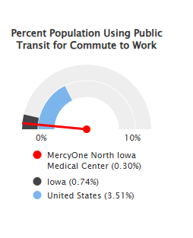
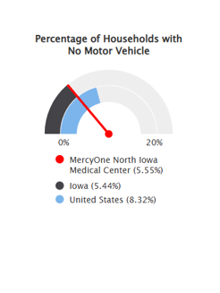

Aging

Survey:
- 8% of the participants identified aging as one of the three most important health concerns in our community.
- 14% of the survey participants reported Medicare as their healthcare insurance.
Focus Group:
- Aging was identified in the focus groups as one of the biggest health challenges people in Mason City face.
- When asked what resources/services are missing or not working well in the community, focus group participants identified the need for a community center for socialization and entertainment for older people withing the community.
- When asked what ideas you have for improving health and wellness in the community, participants identified the need for elderly companionship.
Secondary Data:
- 23.1% of the population is 65 years of age or older.

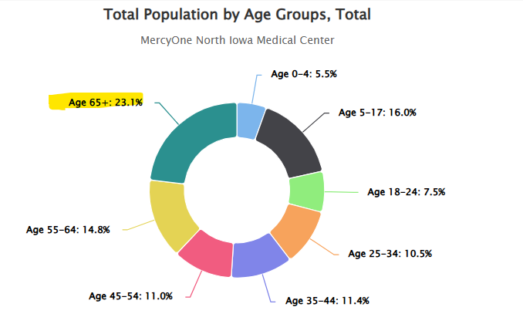

Drug Use/Misuse

Survey:
- 17% of survey participants identified substance abuse (alcohol or other drugs) as one of the three most important health concerns in the Mason City Community. This was the second highest percentage (mental health was the highest).
- 6% of survey participants identified drug and alcohol use as their top three concerns for children (ages 0-17).
- 18% stated that illegal drug misuse is one of the top three adult high-risk behaviors in the community. 8% stated driving while under the influence of alcohol or drugs. 5% stated prescription drug misuse as one of the top three concerns.
- 4% listed access to alcohol/drug treatment as one of their top three strengths of the community.
Focus Group:
- Substance use/misuse was a common theme in focus groups.
- Participants specifically talked about meth use and it being “off the charts” in Mason City.
- Participants identified drug addiction as one of the biggest health challenges people in Mason City face.
- Participants talked a lot about the stigma and how they are treated, even once they are clean and sober.
- Need to be proactive rather than reactive.
- Participants talked about the need for treatment to be “locked” so individuals cannot leave prior to completion.
- Talked about how it is hard to find jobs and housing once you drug use on your record (stigma).
Secondary Data:

Deaths due to poisoning, including drug overdose per 100,000.

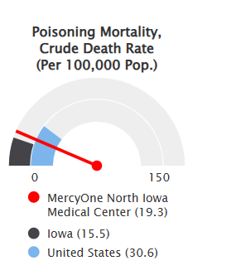

Housing/Homelessness

Survey:
- 1% of the survey participants stated they are currently receiving housing assistance.
- 7% stated within the past 12 months they had trouble paying for housing.
- 4% listed affordable housing as one of the 3 greatest strengths of the community.
Focus Group:
- Participants identified issues with lack of affordable housing, slumlords, and houses unkept.
- Participants identified the need for homeless individuals to have more resources.
- Participants talked about how shelters do not take animals/pets.
- Homeless individuals cannot stay at the shelter if they are suicidal and often the hospital will turn them away, leaving them no other choice than to be on the streets.
Secondary Data:

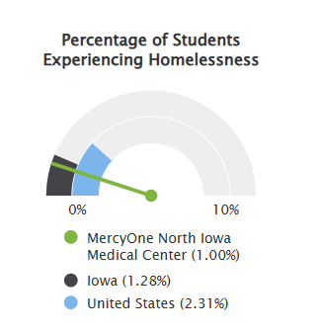

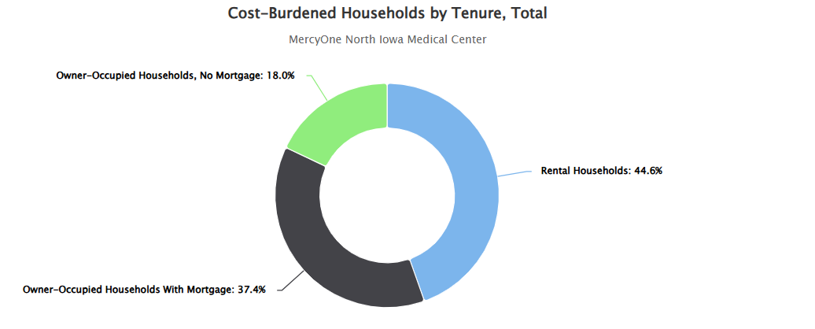

Food/Nutrition

Survey:
- 3% of those who participated in the survey stated they currently have trouble accessing food.
- 5% of the participants are currently receiving food assistance
- 9% of the participants stated within the past 12 months they, or someone in their household, have had trouble paying for food.
- 12% of those surveyed stated access to healthy food as one of the top three concerns for children in the community.
- 12% identified poor diet as one of the top three adult high-risk behaviors of people in the community.
- 4% of the participants stated access to affordable healthy foods as one of the three greatest strengths of the community that helps residents maintain or improve health.
- 18% of participants identified Obesity (#3) as their biggest health concern.
Focus Group:
- Participants talked about the cost of affordable food.
- Identified the need for teaching classes and how to cook healthy food.
- Need to teach people the basics of nutrition and how to understand it.

Secondary Data:

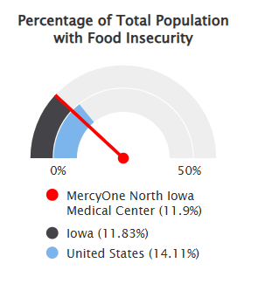 | 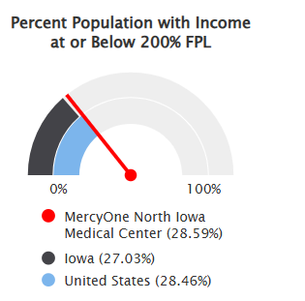 | 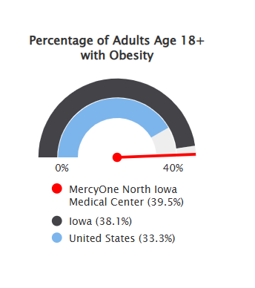

Mental Health

Survey:
- 18% of the survey participants identified mental health as their biggest health concern.
- 10% identified issues accessing mental health
- When asked to rate their overall mental health-30%-Good; 28%-Very Good; 26%-Fair; 11%-Excellent; 6%-Poor
- When asked how to describe their overall mental health:
44%-I am happy on a regular basis and can manage the stress of my everyday life.
24%-I have mental health symptoms/diagnoses, receive help and/or am on medication.
23%-I am sometimes/often lonely, depressed and/or anxious and seek social activity to feel connected.
5%-I struggle with loneliness, depression and/or anxiety and it impacts me often. I receive help from work with these issues but do not take medication.
4%-I am being treated for mental health but still need more.
- When asked about the three most important health concerns in our community, 20% stated mental health (one concern listed).
- When asked what they feel are the top three concerns for children, mental health was the second concern (14%)

Focus Group:
- Focus group participants talked a lot about mental health and the lack of services available.
- Stigma associated with mental health
- Need to improve mental health services
- Case managers only see clients once a month. Feel lonely. Don’t return phone calls timely.
- Participants identified mental health as one of the biggest health concerns.

Secondary Data:

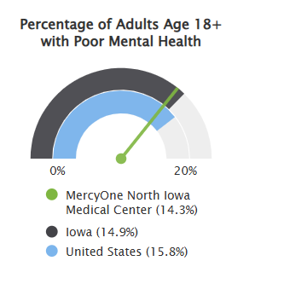
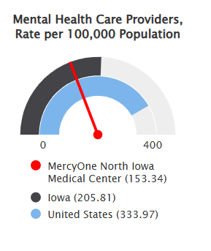

Access to Healthcare

Survey:
- 50% report no issues accessing healthcare while 12% have difficulty accessing general healthcare, 10% mental health & 8% dentist.
- Of the 57% that gave a reason as to why they did not see a doctor, 17% stated long wait time to schedule appointment, 9% state doctor’s office was not open at convenient time, 8% unable to take off work, 7% cost.
- 14% identified issues /concerns in paying for medical care in the past 12 months.
- 9% listed access to healthcare as one of the three greatest strengths of the community.
Focus Group:
- Participants talked about the cost of general healthcare, as well as cost of prescriptions.
- Identified issues/concerns with the doctor/patient relationship (respect and feeling judged based on either present or past behaviors)
- Participants identified issues and concerns with Medicaid and the time it takes to get assistance (once you apply).
- Need free clinics and testing.

Secondary Data:

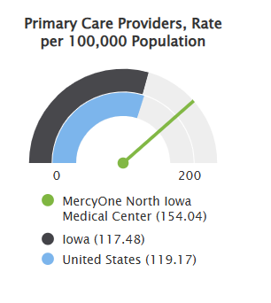
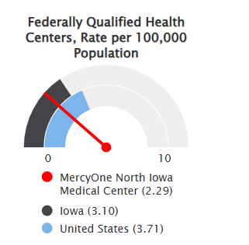

Insurance

Survey:
- 4% of the participants identified issues in accessing health insurance.
- 3% identified lack of insurance as a reason to not receiving mental health services.
- 7% identified affordable health insurance as a top three health concern for children

Focus Group:
- Several participants talked about WellPoint Insurance and how this does not work well in Mason City.

Secondary Data:

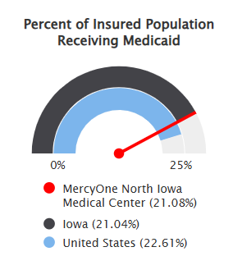
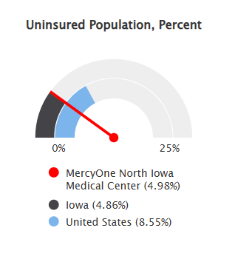

Dentistry

Survey:
- 8% of participants identified trouble with accessing a dentist.
- 79% of the participants state that they have seen the dentist in the last 12 months. Only 7% stated that it has been more than five years since their last dentist visit.
Focus Group:
- Dentistry was discussed at a focus group and identified as one of the biggest health challenges people in Mason City face.

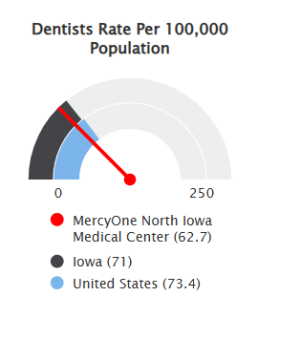
Secondary Data:
Diabetes

Survey:
- 4% of survey participants identified diabetes as one of the three most important health concerns in the community.

Focus Group:
- Participants identified diabetes as one of the biggest health challenges in this community.
- Participants discussed the cost of medication and how supplies are not always available and not affordable.

Secondary Data:
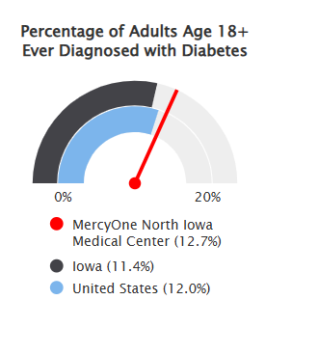
High Blood Pressure (heart disease)

Survey:
- 25% of the participants identified cardiovascular (heart attack, high bp, stoke) as their biggest health concern (followed by mental health).
- When asked what the three most important health concerns in our community are, 2% identified high blood pressure.

Focus Group:
- Work to address blood pressure was identified in a focus group.

Secondary Data:

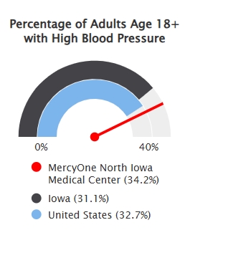

Violence/Harassment/Bullying

Survey:
- 95% of the participants stated they are not afraid of being hurt in their neighborhood.
- 5% identified domestic violence as one of the three most important health concerns in the community.
- 3% identified violence as one of the three most important health concerns in the community.
Focus Group:
- Individuals participating in the focus group identified the need to address violence and shootings.
- Violence/harassment and bullying were mentioned.
Secondary Data:

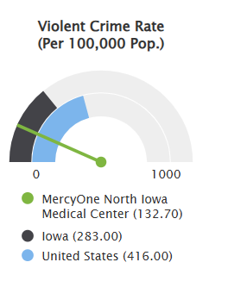

Smoking/Vaping

Survey:
- 5% of participants feel that tobacco/vaping use is one of the top three health concerns for children and 6% identified tobacco/vaping as one of the top three health concerns for adults.

Focus Group:
- Participants identified smoking/vaping as one of the biggest health challenges in the community.

Secondary Data:

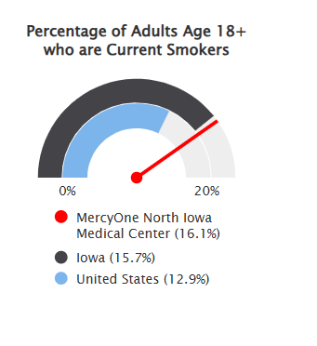

Childcare

Survey:
- 5% of the participants identified trouble accessing childcare.
- One person identified getting childcare assistance
- 2% of the participants stated lack of childcare as the reason for not being able to see a doctor.
- 3% stated that in past 12 months trouble paying childcare.

Focus Group:
- Was not identified in focus group discussions

Secondary Data:
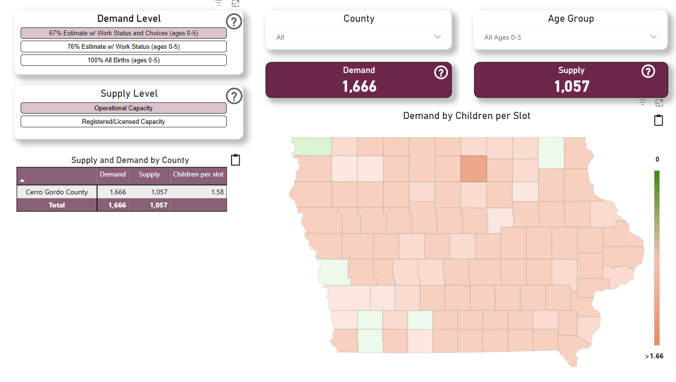
Data Source: Iowa Health and Human Services

Here's a comparison of childcare costs in Mason City, IA to both state and national rates
The cost of hiring childcare providers in Mason City, IA is approximately 7% lower than Iowa average starting rate of $16.43 per hour and 24% lower than the national average of $20.00.
Data Source: Iowa Health and Human Services

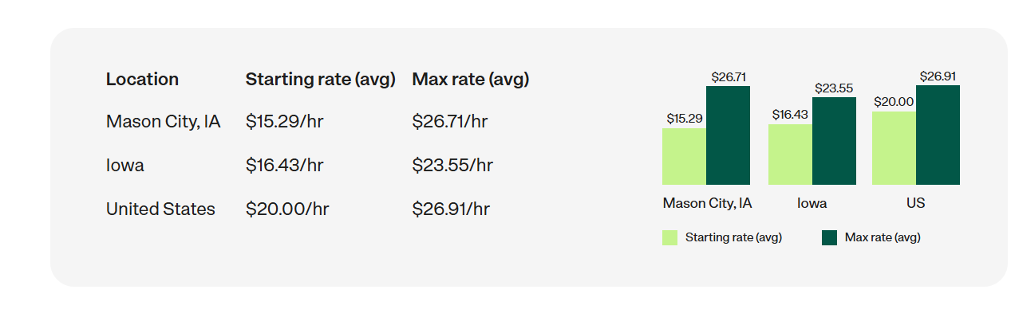
Data Source: Care.com

According to County Health Rankings, Cerro Gordo County, the average household, spends 25% of its income on childcare for two children.

Cancer

Survey:
- 12% of the participants listed cancer as their biggest health concern.
- When asked what the top three most important health concerns of the community, cancer was the third most important (9%).

Focus Group:
- Cancer was not mentioned in the focus groups.

Secondary Data:
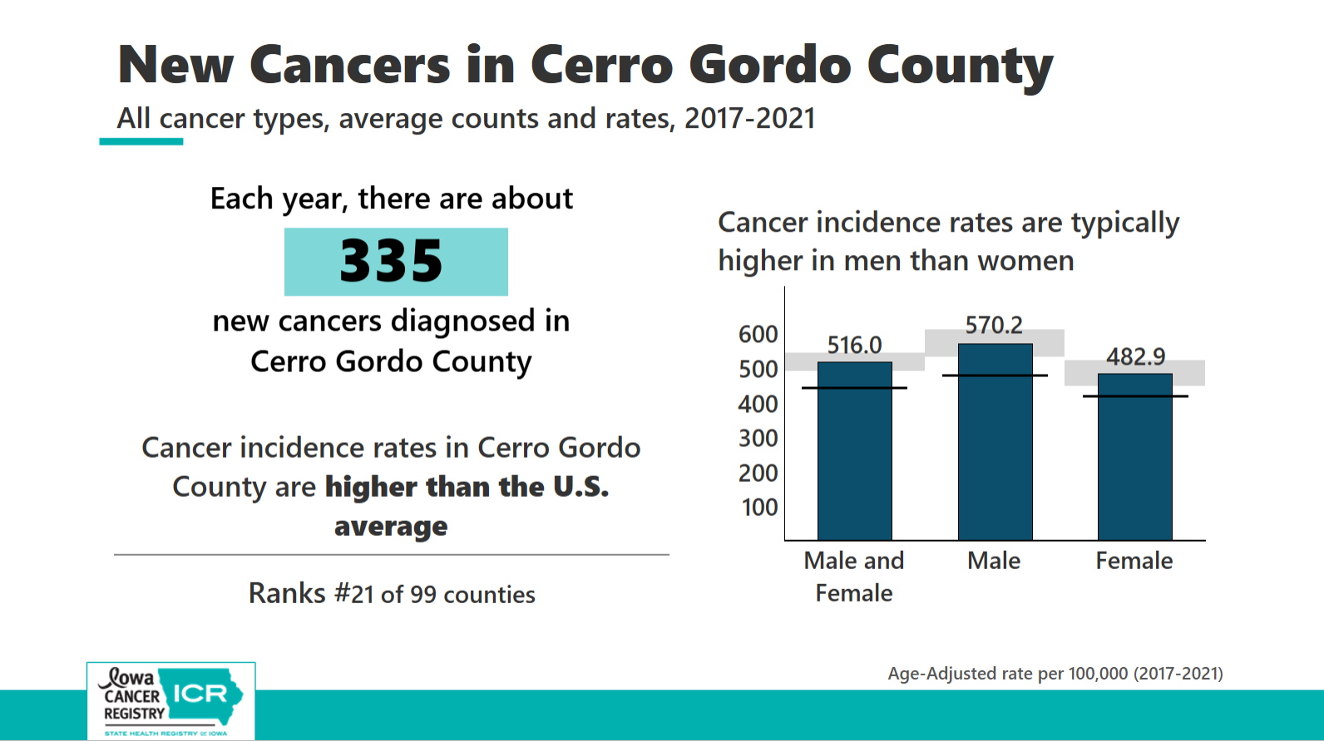
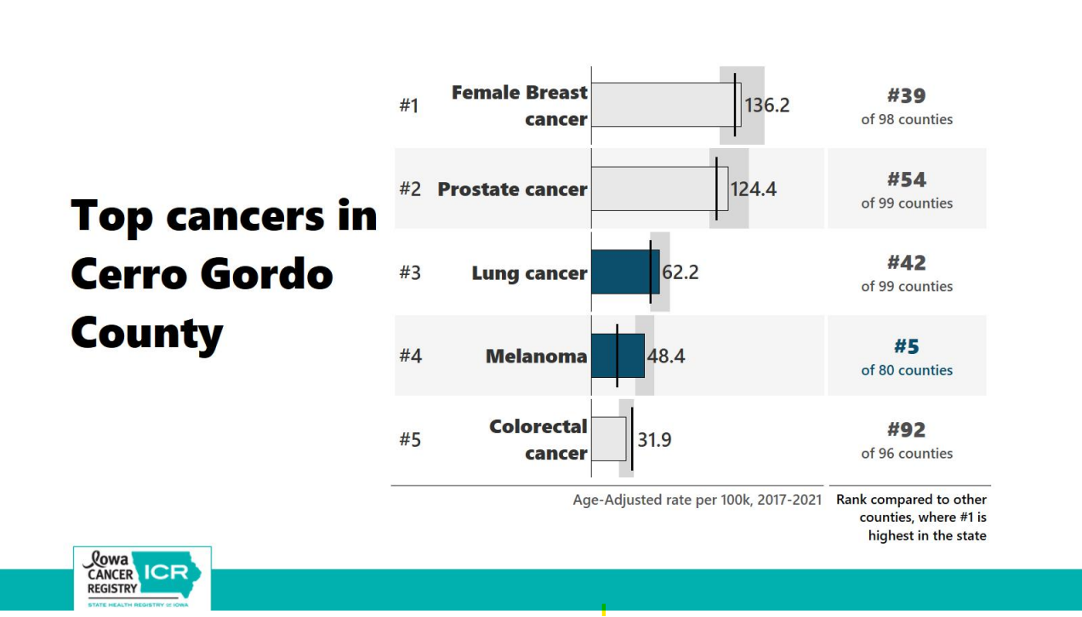

Data Source: Iowa Cancer Registry. State Health Registry of Iowa.

Prioritized needs

Sixteen (16) significant health needs were identified based on the information gathered through community input survey, focus groups, and review of secondary data. Members of the advisory team were asked to rank each of the 16 identified health needs from 1-16, with 1 being highest priority and 16 being lowest priority. Advisory team participants were asked to rank based on the following criteria: number of people impacted, the risk of morbidity and mortality, impact on vulnerable populations, importance to the community, and feasibility of change. The significant community health needs, ranked order of priority, include:
- Food/Nutrition
- Cancer
- Mental Health
- Smoking/Vaping
- Insurance
- Transportation
- Obesity
- Aging
- Childcare
- Diabetes
- High Blood Pressure/Heart Disease
- Access to Healthcare
- Violence/Harassment/Bullying
- Drug Use/Misuse
- Dentistry
- Housing/Homelessness

Community assets and resources
The following are community resources and assets that may be available to address the highest priority health needs.

Food/Nutrition
- Meals on Wheels
- Hawkeye Harvest Food Bank
- Healthy Harvest
- Food for students
- Salvation Army
- Supplemental Nutrition Assistance Program (SNAP)
- Ruby’s Pantry
- Cerro Gordo Public Health
- Double Up Food Bucks
- Women, Infants and Children (WIC)
- Iowa Produce Prescription Program
- Cerro Gordo County Food/Nutrition workgroup
- Community Kitchen of North Iowa
- North Iowa Community Action Organization
Cancer
- Iowa Cancer Consortium
- Cerro Gordo Public Health
- MercyOne Cancer Center
- Pink & Teal Warriors Coalition
- 99 Counties Project
Mental Health
- MercyOne North Iowa
- 43 North Iowa
- Cerro Gordo Public Health work group
- Mid-Iowa Family Therapy
- Families First
- Lutheran Services in Iowa (LSI)
- Prairie Ridge
- NIACC
- Mason City Police Department
- Health IM

Next steps

The current Implementation Strategy will be active. Cancer has been identified as an emerging need. Due to an emerging need being identified, an additional goal will be added, as cancer has been identified as an emerging need. The implementation strategy will be publicly available as a separate document and will be posted to our website once approved by the board.
Printed copies of this report are available upon request at MercyOne North Iowa Medical Center 1000 4th St. SW, Mason City, Iowa 50401. This report is also available electronically at https://www.mercyone.org/about-us/community-health-and-well-being/
Please email questions, comments, and feedback to communityhealth@mercyhealth.com.
The next community needs assessment for MercyOne North Iowa Center will be completed in collaboration with Cerro Gordo Public Health, aligning back into one assessment. This will be completed in FY28.

Secondary indicator data

ACCESS TO CARE

Health insurance

The lack of health insurance is a key driver of health status. People without health insurance are less likely to get the care they need leading to poorer health outcomes. In Cerro Gordo County almost 96%
of residents have health insurance. Of those insured, 22.58% are receiving Medicaid benefits.
- Benchmark: Insured rates in Cerro Gordo County are higher than the state overall (96.25%).
- Healthy People 2030 target: The county insured rate exceeds the Healthy People 2030 target of 92.4% of people having health insurance.
- Disparities: Uninsured rates are highest among males than females in Cerro Gordo County.

Recent primary care visit
Within Cerro Gordo County 78.5% of adults had a routine checkup in the past year.
- Benchmark: Better than state (77.4%) and national (76.1%) rates.
- Data Source(s): Centers for Disease Control and Prevention, Behavioral Risk Factor Surveillance System.

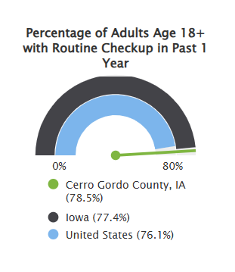

Primary care providers
In Cerro Gordo County, there are 275.93 primary care providers per 100,000 population.
- Comparison: Cerro Gordo County has more primary care providers per 100,000 population than state (117.48) and national (119.17).
- Data source(s): Centers for Medicare and Medicaid Services, CMS - National Plan and Provider Enumeration System (NPPES). November 2025

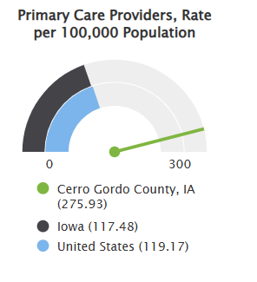

Mental health providers
Cerro Gordo County is a geographic HPSA for mental health. The county 153 providers specializing in mental health translating to a rate of 354.77 mental health providers per 100,000 population.
- Benchmark: Cerro Gordo County has more mental health providers per 100,000 population, exceeding both state and national numbers.
- Data Source(s): Centers for Medicare and Medicaid Services, CMS - National Plan and Provider Enumeration System (NPPES). February 2026.

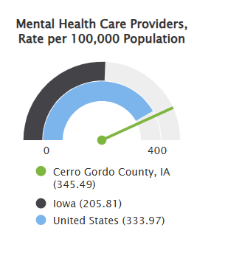

Substance abuse providers
In Cerro Gordo County, there are 108.98 addiction/substance use providers per 100,000 population.
- Benchmark: Cerro Gordo has more substance abuse providers than both the state (30.34) and nation (29.84)
- Data source(s): Centers for Medicare and Medicaid Services, CMS - National Plan and Provider Enumeration System (NPPES). November 2025.

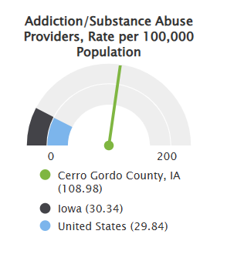

Dentists
In Cerro Gordo County, there are 97 dentists per 100,000 population.
- Benchmark: Cerro Gordo County has more dentists per 100,000 population than both state (71) and nations (73.4)
- Data Source(s): US Department of Health & Human Services, Health Resources and Services Administration, HRSA-2022.

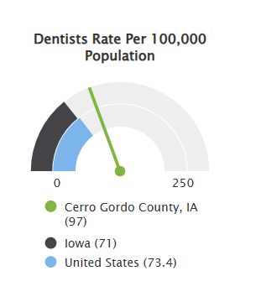

QUALITY OF CARE

Preventable hospitalizations

This indicator reports the preventable hospitalization rate among Medicare beneficiaries for the latest reporting period. Preventable hospitalizations include hospital admissions for one or more of the following conditions: diabetes with short-term complications, diabetes with long-term complications, uncontrolled diabetes without complications, diabetes with lower-extremity amputation, chronic obstructive pulmonary disease, asthma, hypertension, heart failure, bacterial pneumonia, or urinary tract infection. The preventable hospitalization rate in Cerro Gordo County was 2,891 per 100,000 beneficiaries.

- Benchmark: The preventable hospitalization rate in Cerro Gordo County is higher than the state rate of 2,368 and nation of 2,769.
- Data Source(s): Centers for Medicare and Medicaid Services, Mapping Medicare Disparities Tool. 2023.

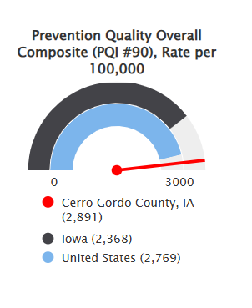

30-day hospital readmissions
This indicator reports the number and rate of 30-day hospital readmissions among Medicare beneficiaries age 65 and older. Hospital readmissions are unplanned visits to an acute care hospital within 30 days after discharge from a hospitalization. Patients may have unplanned readmissions for any reason, however readmissions within 30 days are often related to the care received in the hospital, whereas readmissions over a longer time period have more to do with other complicated illnesses, patients’ own behavior, or care provided to patients after hospital discharge. Cerro Gordo County has a 30-day hospital readmission rate of 14.3%.
- Benchmark: The readmission rate in Cerro Gordo County is better than the state readmission rate of 14.8%.
- Data Source(s): Centers for Medicare and Medicaid Services, CMS - Geographic Variation Public Use File. 2023.

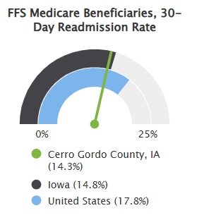

Mammography screening
Over half (60%) of female Medicare enrollees ages 65-74 in Cerro Gordo County received an annual mammography screening.
- Benchmark: Mammography screening rates in Cerro Gordo County are better than the statewide screening rate (54%).
- Data Source(s): County Health Rankings. 2025.

Flu vaccine
During the 2024-2025 flu season, 35% of Cerro Gordo County residents received the flu vaccine.
- Benchmark: The percent of the population receiving the flu vaccine in Cerro Gordo County is similar to the state percentage of 35.6%
- Data Source(s): Iowa Public Health Tracking Portal, Influenza Vaccine Data, 2024-2025 Flu Season.

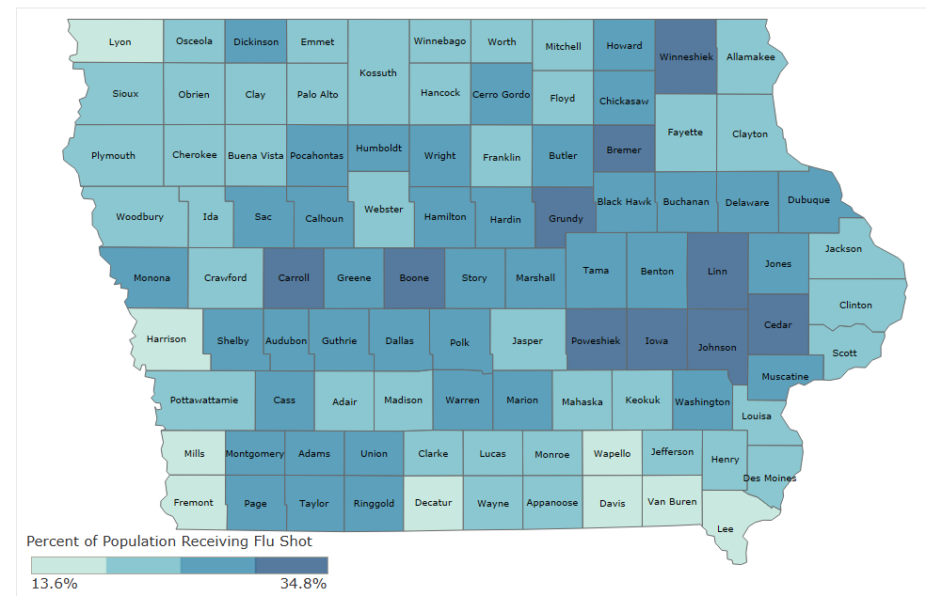

EMPLOYMENT AND INCOME

Labor force participation

Labor force participation rate measures the percentage of working age adults employed or seeking employment. The labor force participation rate in Cerro Gordo County is 64.66%.
- Benchmark: Labor force participation in Cerro Gordo County is higher than the state participation rate (66.50%) and higher than the national participation rate (63.52%).
- Target: Labor force participation in Cerro Gordo County is below the Healthy People 2030 target of 75%.
- Data Source(s): US Census Bureau, 2019-2023 American Community Survey; Healthy People 2030.

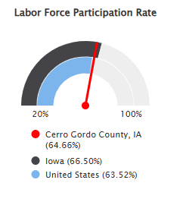

Unemployment rate
Unemployment rate measures the percentage of working age adults employed or seeking employment. The unemployment rate in Cerro Gordo County as of August 2025 was 3.8%. The unemployment rate has increased since August 2024, 3.3%. This indicator is relevant because unemployment creates financial instability and barriers to access including insurance coverage, health services, healthy food and other necessities that contribute to poor health status.
- Benchmark: The unemployment rate in Cerro Gordo County is lower than both state and national rates.
- Data Source(s): US Department of Labor, Bureau of Labor Statistics. 2025

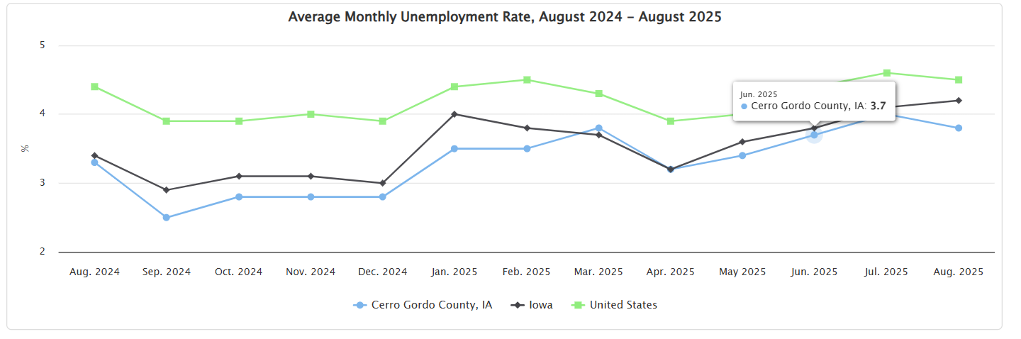

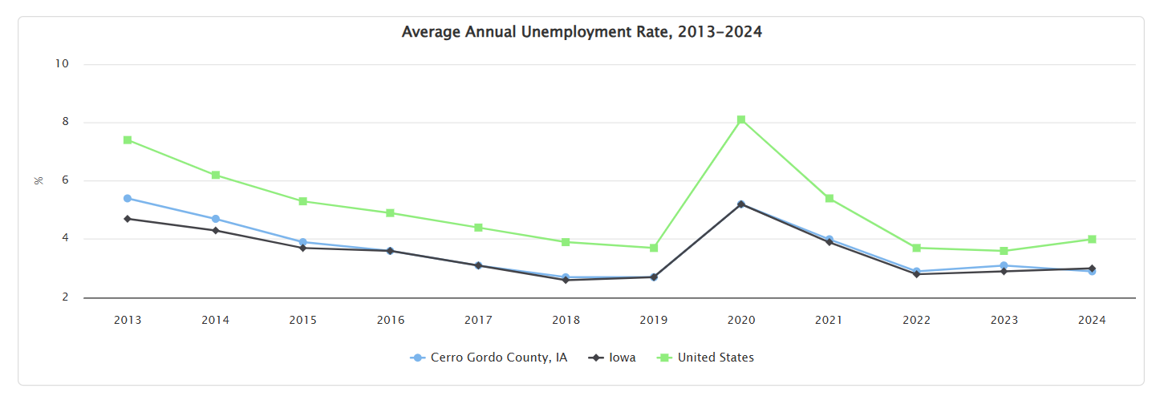

Food insecurity rate
Food insecurity estimates the percentage of the population that experienced food insecurity at some point during the year. The food insecurity rate in Cerro Gordo County in 2023 was 12.0%. Thirty percent of the food insecure population is ineligible for assistance programs (SNAP, WIC, school meals, CSFP, and TEFAP). Food insecurity has been linked to negative health outcomes.
- Benchmark: The food insecurity rate in Cerro Gordo County is slightly higher than the state rate of 11.83%.
- Target: Cerro Gordo County is not achieving the Healthy People 2030 target of 6%.
- Disparities: Food insecurity disproportionately affects children in Cerro Gordo County. The food insecurity rate among children is 16%.
- Data Source(s): Feeding America 2023; Healthy People 2030.

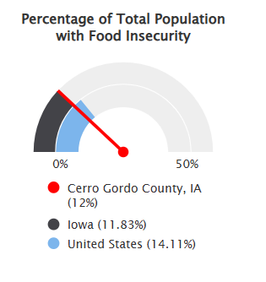

Income
The median household income in Cerro Gordo County is $65,537 (2019-2023).
- Benchmark: The median household income in Cerro Gordo County is lower than the state median of $73,147.
- Disparities: Median household income is much lower among people of color in Cerro Gordo County.
- Data Source(s): US Census Bureau, American Community Survey. 2019-23.

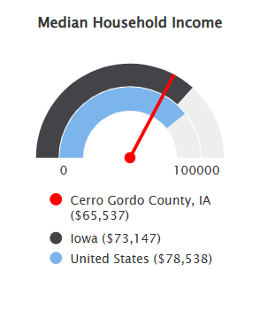

Poverty
Nearly one-third (29.01%) of Cerro Gordo residents live in households with income at or below 200% of the Federal Poverty Level (FPL). The population under 18 living in households below 200% FPL is 37.19%. This indicator is important since poverty creates barriers to access including health services, healthy food, stable housing, and opportunities for physical activity.
- Benchmark: The percentage of individuals living in poverty in Cerro Gordo County is greater than Iowa as a whole (27.03%).
- Target: Cerro Gordo County is not meeting the 8.0% Healthy People 2030 target.
- Data Source(s): US Census Bureau, American Community Survey. 2019-23 Healthy People 2030; 2021

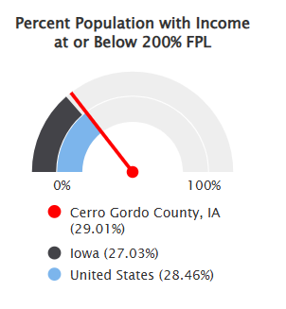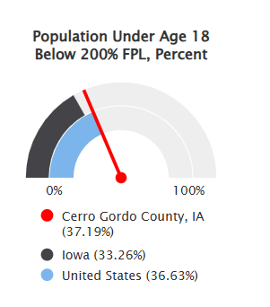

Children eligible for free/reduced-price lunch
Nearly half of public-school students in Cerro Gordo County were eligible for free or reduced-price lunch. Free or reduced-price lunches are served to qualifying students in families with income under 185% (reduced-price) or under 130% (free lunch) of the US federal poverty threshold as part of the National School Lunch Program (NSLP).
- Benchmark: The percentage of children eligible for free or reduced-price lunch is higher in Cerro Gordo County than the state as a whole (41.4%).
- Data Source(s): National Center for Education Statistics, NCES-Common Care of Data 2023-24.

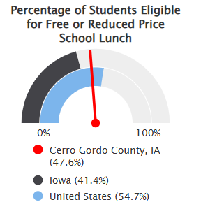

EDUCATION

Head Start

Head Start is a program designed to help children from birth to age five who come from families at or below poverty level. Cerro Gordo County has three Head Start programs, a rate of 13.68 per 10,000 children. This indicator is important because the program’s goal is to help children become ready for kindergarten while also providing the needed requirements to thrive, including health care and food support.
- Benchmark: Cerro Gordo County has a lower rate of head start programs than the state as a whole (14.21).

- Data Source(s): US Department of Health and Human Services (HHS), HRSA-Administration for Children and Families. 2025.

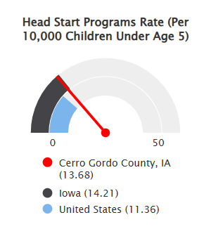

Preschool
Cerro Gordo County has 383 children age 3-4 enrolled in school, which is 39.98% of the county population age 3-4.
- Benchmark: There are less children aged 3-4 enrolled in school compared to the state (42.95%) and nationally (45.57%)
- Data Source(s): US Census Bureau, American Community Survey. 2019-23.

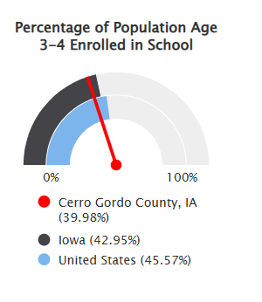

Chronic absenteeism
This indicator reports the rate of chronic absenteeism (students absent 10% or more school days during the school year 2022-2023). In Cerro Gordo County 25.0% or 1,356 children were chronically absent during the 2022-23 school year.
- Benchmark: Absenteeism in Cerro Gordo County is higher than Iowa as a whole (23.5%).
- Disparities: Chronic absenteeism is higher among Native Hawaiian/Other Pacific Islander population in Cerro Gordo County.
- Data Source(s): Us Department of Education, ED Data Express. Additional data analysis by CARES. 2022-2023

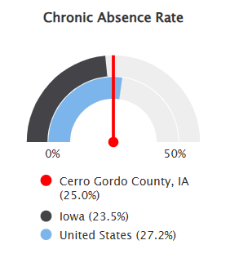

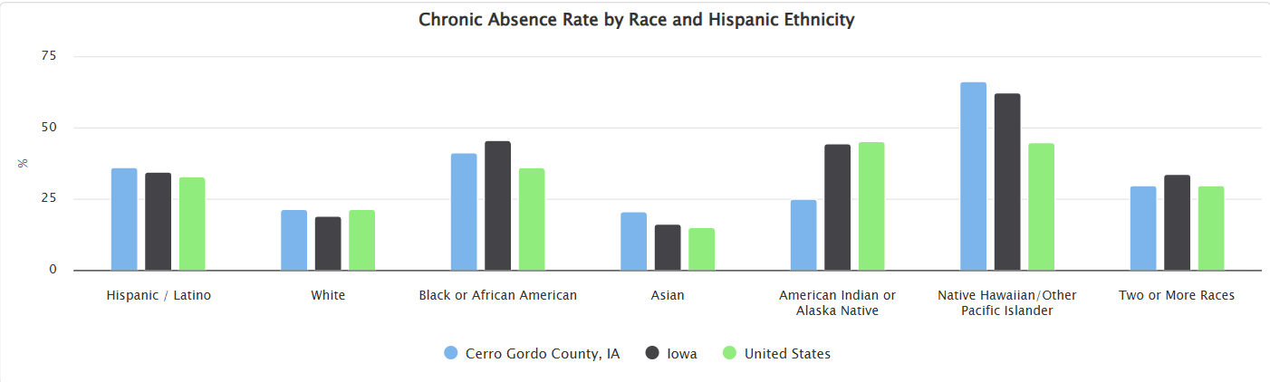

Student reading proficiency (4th grade)
In Cerro Gordo County, almost 75% of 4th grade students had reading skills at or above the proficient level.
- Benchmark: Students in Cerro Gordo County (74.9%) performed better than students statewide (46.7%).
- Target: Cerro Gordo County is performing above the Healthy People 2030 target of 41.5%
- Data Source(s): US Department of Education, ED Data Express. Additional data analysis by CARES. 2021-22.

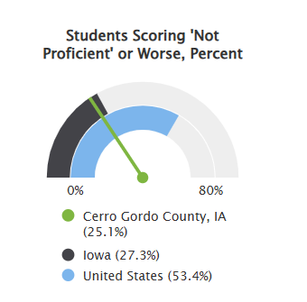

High school diploma
In Cerro Gordo County nearly 95% of the population age 25 or older has a high school diploma or equivalent. This indicator is important because educational attainment is linked to positive health outcomes.
- Benchmark: High school graduation rates in Cerro Gordo County are higher than the state as a whole (93%).
- Disparities: The percentage of the population without a high school diploma is much higher in the Hispanic or Latino population.
- Data Source(s): US Census Bureau, American Community Survey. 2019-23.

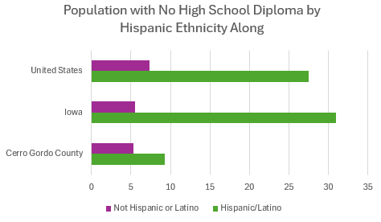

Bachelor’s degree or higher
About a quarter (24.26%) of Cerro Gordo County residents age 25 or older have obtained a bachelor’s degree or higher. According to Healthy People 2030, higher education helps people secure better-paying jobs with fewer safety hazards. Income from these employment opportunities may improve health by increasing people’s ability to accrue material resources, such as higher- quality housing, as well as psychosocial resources, such as higher social status.
- Benchmark: The percentage of Cerro Gordo County residents with a bachelor’s degree or higher is lower than the state (30.86%).
- Data Source(s): US Census Bureau, American Community Survey. 2019-23.

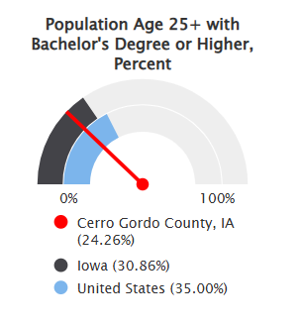

Young people not in school and not working
This indicator reports the percentage of youth age 16-19 who are not currently enrolled in school and who are not employed. More than 6% of youth in Cerro Gordo County are not in school and not employed.

- Benchmark: The percentage of youth who are not enrolled in school and who are not employed is higher in Cerro Gordo County (6.08%) than the state of Iowa (5.47%).
- Target: The healthy people 2023 target is to decrease the number of adolescents and young adults aged 16 to 24 years who are enrolled in neither school nor working to 10.1%.
- Data Source(s): US Census Bureau, American Community Survey. 2019-23; Health People 2030.

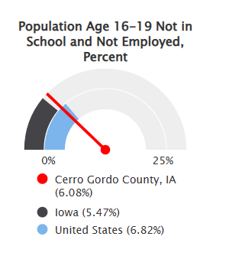

COMMUNITY SAFETY

Violent crime

Within Cerro Gordo County, the 2015-2017 three-year total of reported violent crimes was 220, which equates to an annual rate of 171 crimes per 100,000 people. Violent crime includes homicide, rape, robbery, and aggravated assault.
- Benchmark: The rate of violent crimes in Cerro Gordo County is lower than the state rate of 283.00.
- Data Source(s): Federal Bureau of Investigation, FBI Uniform Crime Reports.

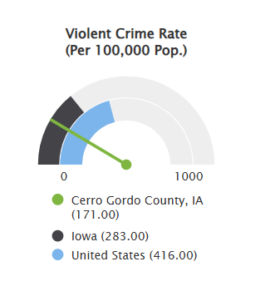

Alcohol-impaired driving deaths
The number of alcohol impaired driving deaths in Cerro Gordo County has decreased from 38% (2018-2022 data) to 36% (2019-2023 data).
- Benchmark: The percentage of alcohol impaired deaths in Cerro Gordo County (36%) are higher than the state (26%).
- Data Source(s): 2025 County Health Rankings, which utilizes figures from the 2019-2023

SOCIAL AND COMMUNITY

Broadband access

Nearly all (99.54%) of Cerro Gordo County residents have access to high-speed internet. Data is based on the reported service area of providers offering download speeds of 25 MBPS or more and upload speeds of 3 MBPS or more.
- Benchmark: Access to broadband in Cerro Gordo County is slightly higher than the state as a whole (98.24%).
- Data Source(s): FCC FABRIC Data. Additional data analysis by CARES. 2025.

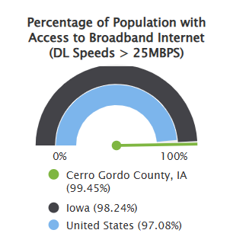

Park access
Just over 60% (60.55%) of Cerro Gordo County live within half a mile of a park. This indicator is relevant because access to outdoor recreation encourages physical activity and other healthy behaviors.
- Benchmark: A greater proportion of Cerro Gordo County residents have park access than Iowa as a whole (46.36%).
- Data Source(s): Trust for Public Land. 2025

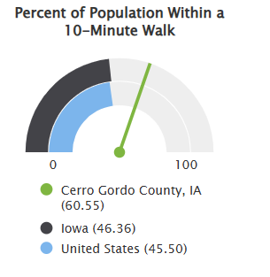

Social associations
Cerro Gordo County has 162.31 social establishments per 100,000 population. Associations include membership organizations such as civic organizations, bowling centers, golf clubs, fitness centers, sports organizations, political organizations, labor organizations, business organizations and professional organizations.
- Benchmark: Cerro Gordo County has a higher rate of social establishments than the state (145.85).
- Data Source(s): US Census Bureau, County Business Patterns. Additional data analysis by CARES. 2022.

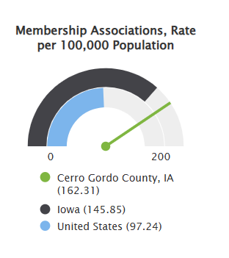

AIR AND WATER QUALITY

Air pollution

Cerro Gordo County has an annual average of 7.1 micrograms per cubic meter of fine particulate matter measured in the air.
- Benchmark: The average density of particulate matter in the air is lower in Cerro Gordo County than Iowa as a whole (7.4).
- Data Source(s): County Health Rankings, 2025.

Drinking water safety
This indicator reports presence or absence of one or more health-based violations in drinking water within community water systems that serve the community. No community water system in Cerro Gordo County reported a health-based drinking water violation.

- Data Source(s): County Health Rankings, 2025.

HOUSING AND TRANSPORTATION

Households with no motor vehicle
Over 5% (5.34%) of households in Cerro Gordo County do not have a motor vehicle.
- Benchmark: Cerro Gordo County has slightly fewer households without a motor vehicle, compared to the state (5.44%)
- Disparities: Within the service area, there are significantly more renter-occupied households with no vehicle (13.95%) than owner-occupied households (1.94%).
Data Source(s): US Census Bureau, American Community Survey. 2019-2023.

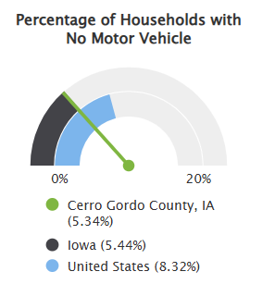

Housing costs
A total of 18.71% of households in Cerro Gordo County have housing costs 18.71% of their total household income. This indicator provides information on the cost of monthly housing expenses for owners and renters. The information offers a measure of housing affordability and excessive shelter costs.
- Benchmark: The percentage of cost-burdened households in Cerro Gordo County is lower than the Iowa rate of 22.13%.
- Disparities: Rental households are more cost-burdened than owner-occupied households.
- Data Source(s): US Census Bureau, American Community Survey. 2019-23.

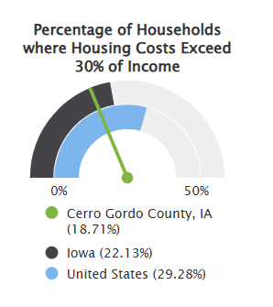

.

Overcrowded housing
A total of 1.18% of households in Cerro Gordo County are overcrowded. Overcrowding is defined as more than one occupant per room.
- Benchmark: The percentage of overcrowded households in Cerro Gordo County is slightly lower than the Iowa (1.18%).
- Disparities: The Mason City area of the county has higher rates of overcrowding (over 4%).
- Data Source(s): US Census Bureau, American Community Survey. 2019-23.

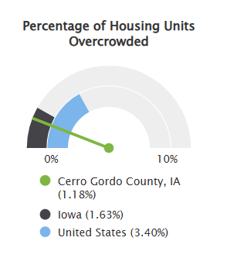
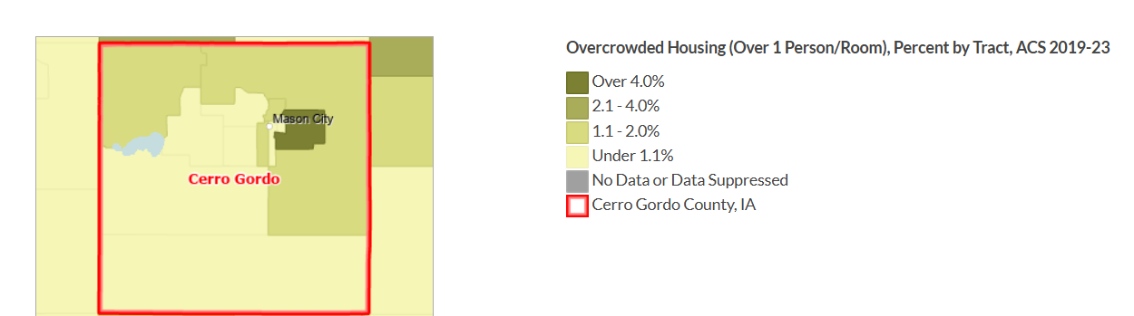

Substandard housing
This indicator reports the number and percentage of owner- and renter-occupied housing units having at least one of the following conditions: 1) lacking complete plumbing facilities, 2) lacking complete kitchen facilities, 3) with one or more occupants per room, 4) selected monthly owner costs as a percentage of household income greater than 30%, and 5) gross rent as a percentage of household income greater than 30%. Selected conditions provide information assessing the quality of the housing inventory and its occupants. This data is used to easily identify homes where the quality of living and housing can be considered substandard. Of the 19,421 total occupied housing units in the report area, 4,015 or 20.67% have one or more substandard conditions.
- Benchmark: The percentage of housing units with substandard conditions in Cerro Gordo County is lower than the Iowa rate of 23.84%. The only condition where Cerro Gordo County performs more poorly than the state is housing units lacking a complete kitchen. Almost 1.15 percent of housing units in Cerro Gordo County lack a complete kitchen compared to the Iowa average of .8
- Data Source(s): US Census Bureau, American Community Survey. 2019-23.

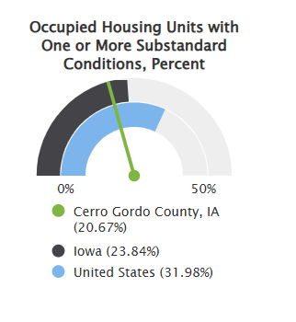

MATERNAL, INFANT, AND CHILD HEALTH

Infant mortality
Cerro Gordo County has an infant mortality rate of 7.0 per 1,000 live births. The mortality rate is highest in infants between 28 days of age and one year of age.
- Benchmark: The infant mortality rate is higher in Cerro Gordo County than the state of Iowa (5.0 per 1,000 live births).
- Data Source(s): University of Wisconsin Population Health Institute, County Health Rankings. 2016-2022.

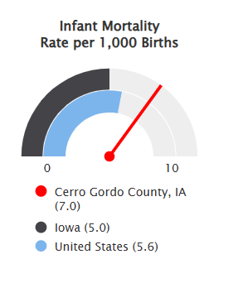

Low birth weight
Nearly 8% of infants born in Cerro Gordo County had a low birth weight. Low birth weight is defined as less than 2,500 grams (approximately 5 lbs., 8 0z.).
- Benchmark: The prevalence of infants born at a low birth weight is higher in Cerro Gordo County than Iowa as a whole (7.0%).
- Disparity: A greater proportion of Non-Hispanic Black Cerro Gordo residents have a higher rate of low birth weight.
- Data Source(s): University of Wisconsin Population Health Institute, County Health Rankings. 2017-2023.

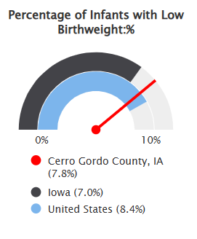

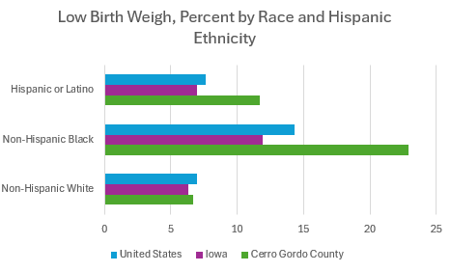

Teen Births
This indicator reports the seven-year average number of births per 1,000 female population age 15-
- In Cerro Gordo County, the teen birth rate is 16.8 per 1,000.
  - Benchmark: The teen birth rate in Cerro Gordo County is higher than the state’s teen birth rate of 13.7.
  - Disparities: The teen birth rate among Hispanic or Latino females (50.2) is much higher than Non-Hispanic White Females (16.4).
  - Data Source(s): Centers for Disease Control and Prevention, CDC-National Vital Statistics System, Accessed via County Health Rankings. 2017-2023.

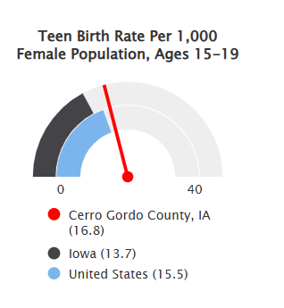

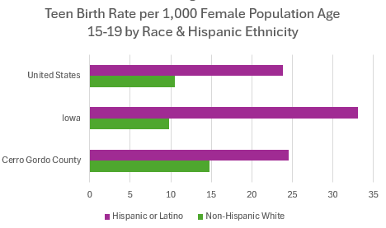

Infants ever breastfed
The breastfeeding initiation rate in Cerro Gordo County was 80% in 2023. This indicator is defined as the percentage of births where breastfeeding was initiated prior to hospital discharge for the delivery.
  - Benchmark: Cerro Gordo County has a lower breastfeeding initiation rate than the state (84%).
  - Data Source(s): Iowa Public Health Tracking Portal. Infants Ever Breastfed. 2023.

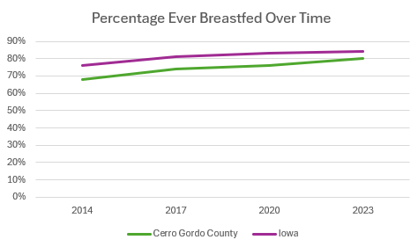

Child immunization
Over 70% (71.2%) of children in Cerro Gordo County received the recommended doses of the 4:3:1:3:3:1:4 series by age 24 months of age.
  - Benchmark: The immunization rate in Cerro Gordo County is slightly higher than the Iowa vaccination rate (70.4%).
  - Data Source(s): Iowa Public Health Tracking Portal. Children: Immunization Data for 2-Year-Old. 2025.

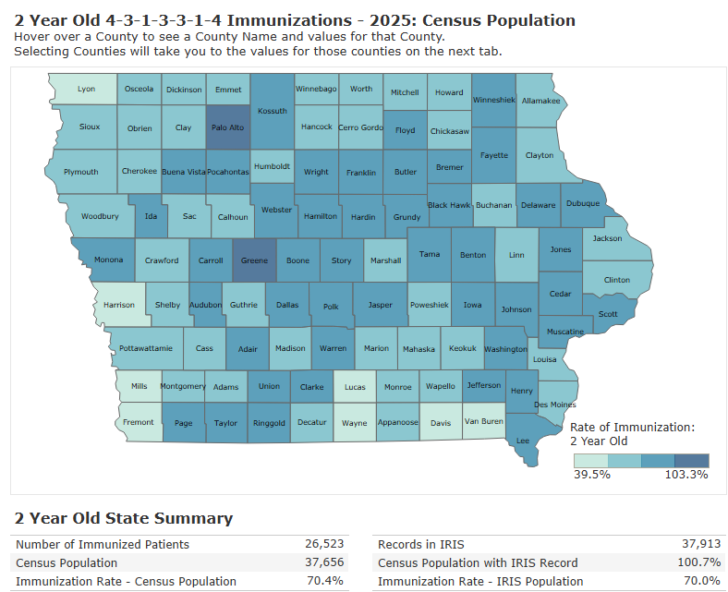

Child abuse
Cerro County had a Child Abuse rate of 21.7 per 1,000 children in 2020, children age 0-17.
  - Benchmark: The child abuse rate in Cerro Gordo County is higher than the statewide rate of 14.5.
  - Data Source(s): Kids Count Data Center. Child abuse and neglect in Iowa. 2020.

Location: | 2011 | 2012 | 2013 | 2014 | 2015 | 2016 | 2017 | 2018 | 2019 | 2020
Cerro Gordo | 27.1 | 24.7 | 24.1 | 13.1 | 17.8 | 15.6 | 15.8 | 26 | 24.4 | 21.7
Iowa | 16.1 | 16.1 | 17 | 10.2 | 11.4 | 12.2 | 12.9 | 15.8 | 15.7 | 14.5

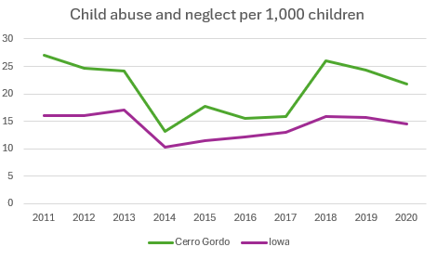

HEALTH BEHAVIORS AND RISK FACTORS

Current smokers
Within Cerro Gordo County, 15.5% of adults report having smoked at least 100 cigarettes in their lifetime and currently smoke every day or some days.
  - Benchmark: The proportion of adults who are current smokers in Cerro Gordo County is higher than that of the state (15.5%).
  - Data Source(s): Centers for Disease Control and Prevention, Behavioral Risk Factor Surveillance System. 2023.

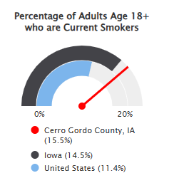

Physical inactivity
In Cerro Gordo County, 27% of adults reported no leisure-time physical activity outside of work (age- adjusted).
  - Benchmark: Cerro Gordo County residents are less active than their Iowa peers (24.8%).
  - Data Source(s): County Health Rankings. 2023.

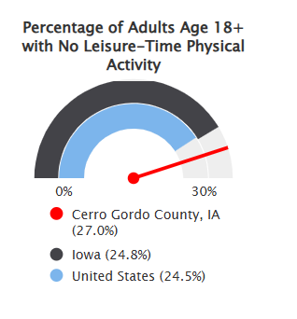

Obesity
A total of 40.1% of Cerro Gordo County adults are obese, defined as having a BMI of ≥30.0 kg/m².
  - Benchmark: Obesity is slightly higher in Cerro Gordo County than in the state (37.7%).
  - Data Source(s): Centers for Disease Control and Prevention, Behavioral Risk Factor Surveillance System. 2023.

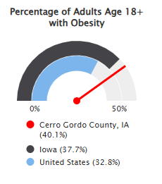

Grocery stores and supermarkets
Cerro Gordo County has 30.14 grocery establishments per 100,000 population. Healthy dietary behaviors are supported by access to healthy foods, and grocery stores are a major provider of these foods. Grocery stores are defined as supermarkets and smaller grocery stores primarily engaged in retailing a general line of food, such as canned and frozen foods, fresh fruits and vegetables and fresh and prepared meats, fish and poultry. Delicatessen-type establishments are also included. Convenience stores and large general merchandise stores that also retail food, such as supercenters and warehouse club stores, are excluded.
  - Benchmark: Cerro Gordo County residents have better access to grocery establishments than Iowans as a whole (19.03 per 100,000).
  - Data Source(s): US Census Bureau, County Business Patterns. Additional data analysis by CARES. 2023.

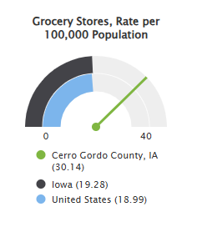

Excessive drinking
Nearly a quarter (23%) of Cerro Gordo County adults report binge or heavy drinking.
  - Benchmark: Cerro Gordo County residents report slightly less binge/heavy drinking their Iowa peers (25%).
  - Data Source(s): County Health Rankings. 2023.

Chlamydia
In Cerro Gordo County, 295 new cases of chlamydia were diagnosed per 100,000 population in 2024.
  - Benchmark: The rate of chlamydia diagnosis in Cerro Gordo County is lower than the state rate (375 per 100,000 population).
  - Data Source(s): Iowa Public Health Tracking Portal. Chlamydia Data. 2024.

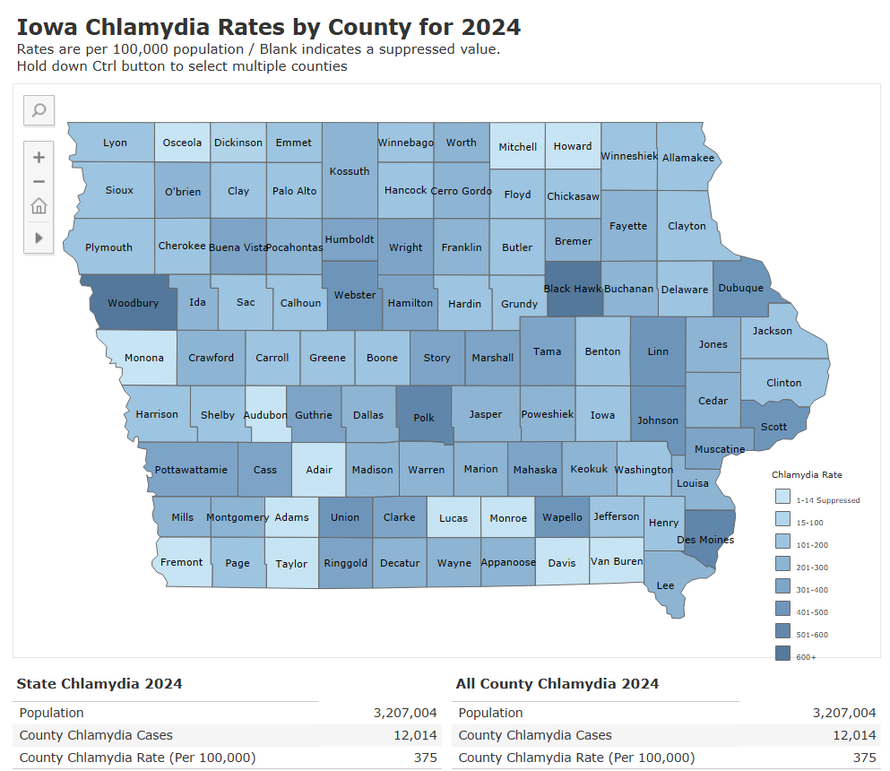

HIV diagnosis
The prevalence of HIV disease in Cerro Gordo County is 78.1 per 100,000 residents.
  - Benchmark: The prevalence in Cerro Gordo County is lower than the state (110 per 100,000 residents).
  - Data Source(s): State of Iowa Department of Health and Human Services. State of Iowa HIV Disease End of Year 2022 Surveillance Report.

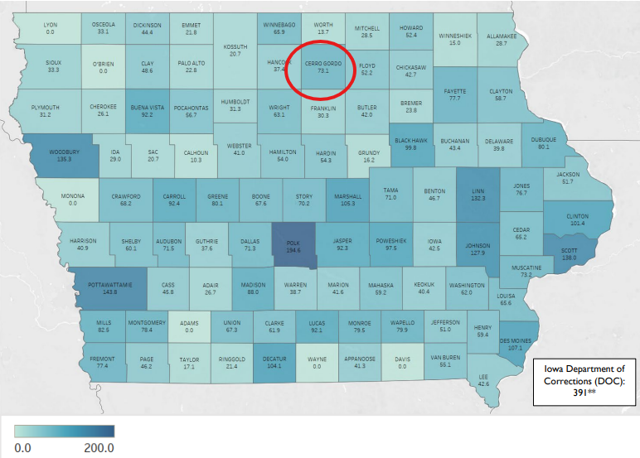

CHRONIC DISEASES

Cancer incidence

The age-adjusted cancer incidence rate in Cerro Gordo County is 516 per 100,000 population. The top five most commonly diagnosed cancers in Cerro Gordo County include prostate cancer, breast cancer, lung and bronchus cancer, colon and rectal cancer and bladder cancer.
  - Benchmark: The cancer incidence rate in Cerro Gordo County is higher than the state rate (491.8).
  - Data Source(s): State Cancer Profiles. 2017-21.

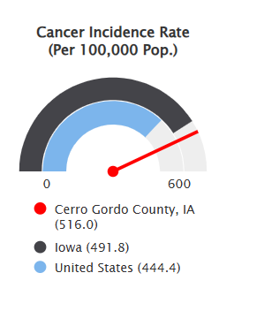

Diabetes
Nearly 12.5% percent of adults in Cerro Gordo County have been told by a health care professional that they have diabetes (excludes gestational diabetes).
  - Benchmark: The percentage of adults with diabetes in Cerro Gordo County (12.5%) is higher than that of the state as a whole (11.2%).
  - Data Source(s): Centers for Disease Control and Prevention, Behavioral Risk Factor Surveillance System. Accessed via the PLACES Data Portal. 2023.

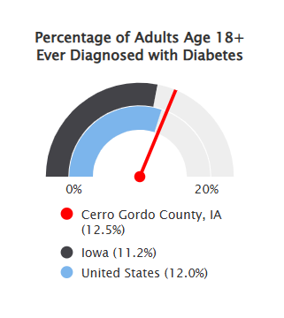

Alzheimer’s disease
Nearly 10.2% percent of Medicare Fee-For-Service beneficiaries in Cerro Gordo County are living with Alzheimer’s disease.
  - Benchmark: The percentage of beneficiaries with Alzheimer’s disease in Cerro Gordo County is slightly higher than the state as a whole (9.6%).
  - Data Source(s): Centers for Medicare & Medicaid Services, Centers for Medicare & Medicaid Services - Chronic Conditions. 2018.

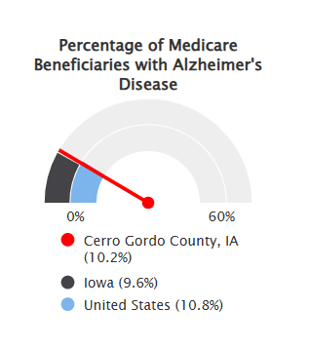

High blood pressure
More than a third (37.6%) of the adults age 18 or older have been told by a doctor, nurse or other health professionals that they have high blood pressure.
  - Benchmark: Cerro Gordo County has a higher percentage of adults 18 and older with high blood pressure than both the state (37.6%) and nation (34.4%).
  - Data Source(s): Centers for Disease Control and Prevention, Behavioral Risk Surveillance System. 2023.

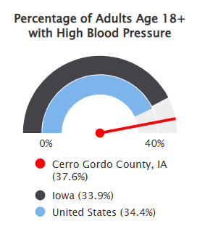

Heart disease
Under a quarter (19%) of Medicare Fee-For-Service beneficiaries in Cerro Gordo County are living with ischemic heart disease.
  - Benchmark: The percentage of Medicare Fee-For-Service beneficiaries with ischemic heart disease in Cerro Gordo County is slightly higher than Iowa as a whole (18.0%).
  - Data Source(s): Centers for Medicare & Medicaid Services, Centers for Medicare & Medicaid Services - Chronic Conditions. 2018.

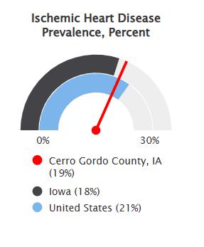

QUALITY OF LIFE

Poor physical health days

Within Cerro Gordo County, 13.5% of adults reported having 14 or more days during the past 30 days during which their physical health was not good.
  - Benchmark: A larger percentage of adults in Cerro Gordo County (13.5%) reported poor physical health days than Iowa (12.7%).
  - Data Source(s): Centers for Disease Control and Prevention, Behavioral Risk Factor Surveillance System. 2023.

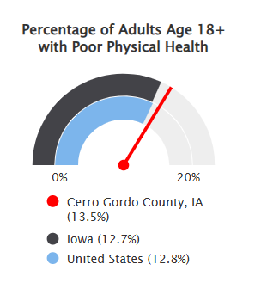

Poor or fair health
Within Cerro Gordo County, 16% of adults report having poor or fair health.
  - Benchmark: The percentage of adults reporting poor or fair health in Cerro Gordo County is the same as the state rate (16%).
  - Data Source(s): Centers for Disease Control and Prevention, Behavioral Risk Factor Surveillance System. 2022.

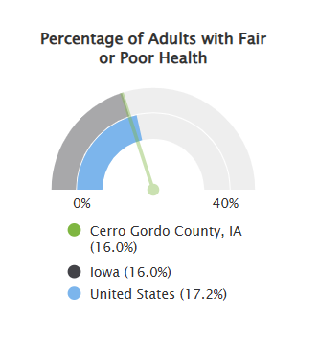

Poor mental health
Within Cerro Gordo County, 15.9% of adults reported poor mental health in the past 30 days.
  - Benchmark: The percentage of adults reporting poor mental health in Cerro Gordo County is slightly lower than the state rate (16.4%).
  - Data Source(s): Centers for Disease Control and Prevention, Behavioral Risk Factor Surveillance System. 2023.

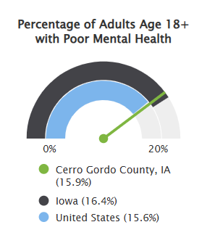

LIFE EXPECTANCY

Leading cause of death

The leading cause of death in Cerro Gordo County is heart disease at 19.9 per 10,000 followed by malignant neoplasms (cancer) at 12.3 per 10,000.
  - Benchmark: The age-adjusted death rate due to heart disease is higher in Cerro Gordo at 19.9 per 10,000 than the Iowa rate of 17.2 per 10,000. Cerro Gordo County also has a higher rate of accidents (unintentional injury) at 4.0 per 10,000 compared to the Iowa rate of 3.3 per 10,000. Cerro Gordo County also has an higher age-adjusted death rate due to Alzheimer’s disease of 4.0 per 10,000 compared to the Iowa rate of 2.2 per 10,000.
  - Data Source(s): Iowa Public Health Tracking Tool. 2024.

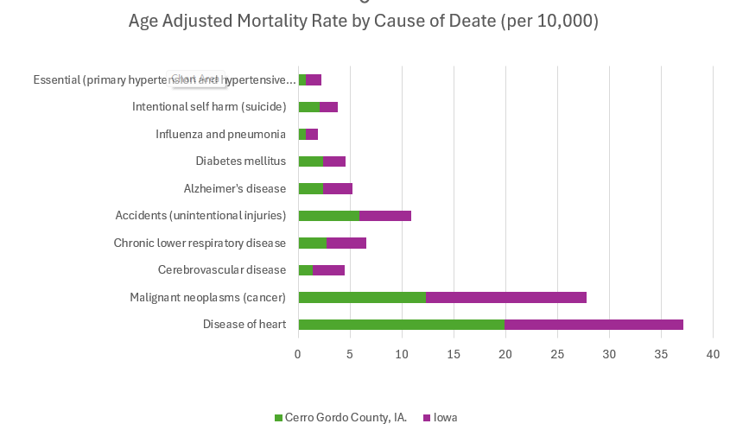

Life expectancy
The average age-adjusted life expectancy at birth in Cerro Gordo County is 76.5 years.
  - Benchmark: The life expectancy in Cerro Gordo County (76.5) is lower than the state life expectancy (77.8 years).
  - Data Source(s): University of Wisconsin Population Health Institute, County Health Ranking

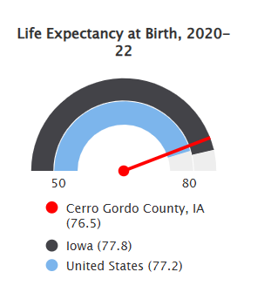

Cancer mortality
The age-adjusted death rate due to cancer in Cerro Gordo County is 245.7 per every 100,000 population.
  - Benchmark: The cancer mortality rate is lower in Cerro Gordo County is significantly higher than the state (198.4).
  - Data Source(s): Centers for Disease Control and Prevention, CDC - National Vital Statistics System. Accessed via CDC WONDER. 2019-2023.

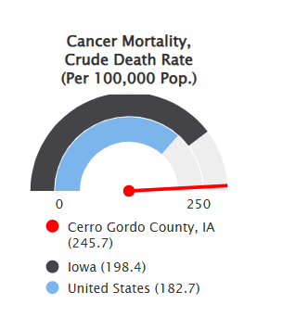

Lung disease mortality
The age-adjusted death rate due to lung disease in Cerro Gordo County is 62.2 per every 100,000 population.
  - Benchmark: The lung disease mortality rate is higher in Cerro Gordo County than the state (54.7 per 100,000).
  - Disparity: Lung disease mortality rate is much higher among females (63.9) than males (60.6) than in Cerro Gordo County.
  - Data Source(s): Centers for Disease Control and Prevention, CDC - National Vital Statistics System. Accessed via CDC WONDER. 2019-2023.

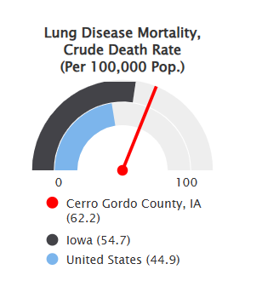

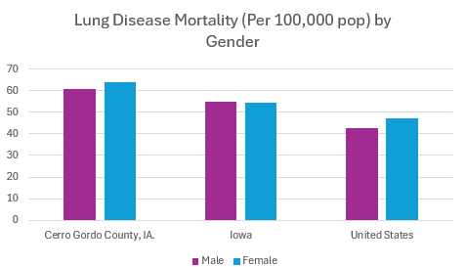

Coronary heart disease mortality
The age-adjusted death rate due to coronary heart disease in Cerro Gordo County is 188.6 per every 100,000 population.
  - Benchmark: The heart disease mortality rate is lower in Cerro Gordo County is higher than the state (136.8).
  - Data Source(s): Centers for Disease Control and Prevention, CDC - National Vital Statistics System. Accessed via CDC WONDER. 2019-2023.

